Engineering Design Methods

Coursework 3
African Medical Transport

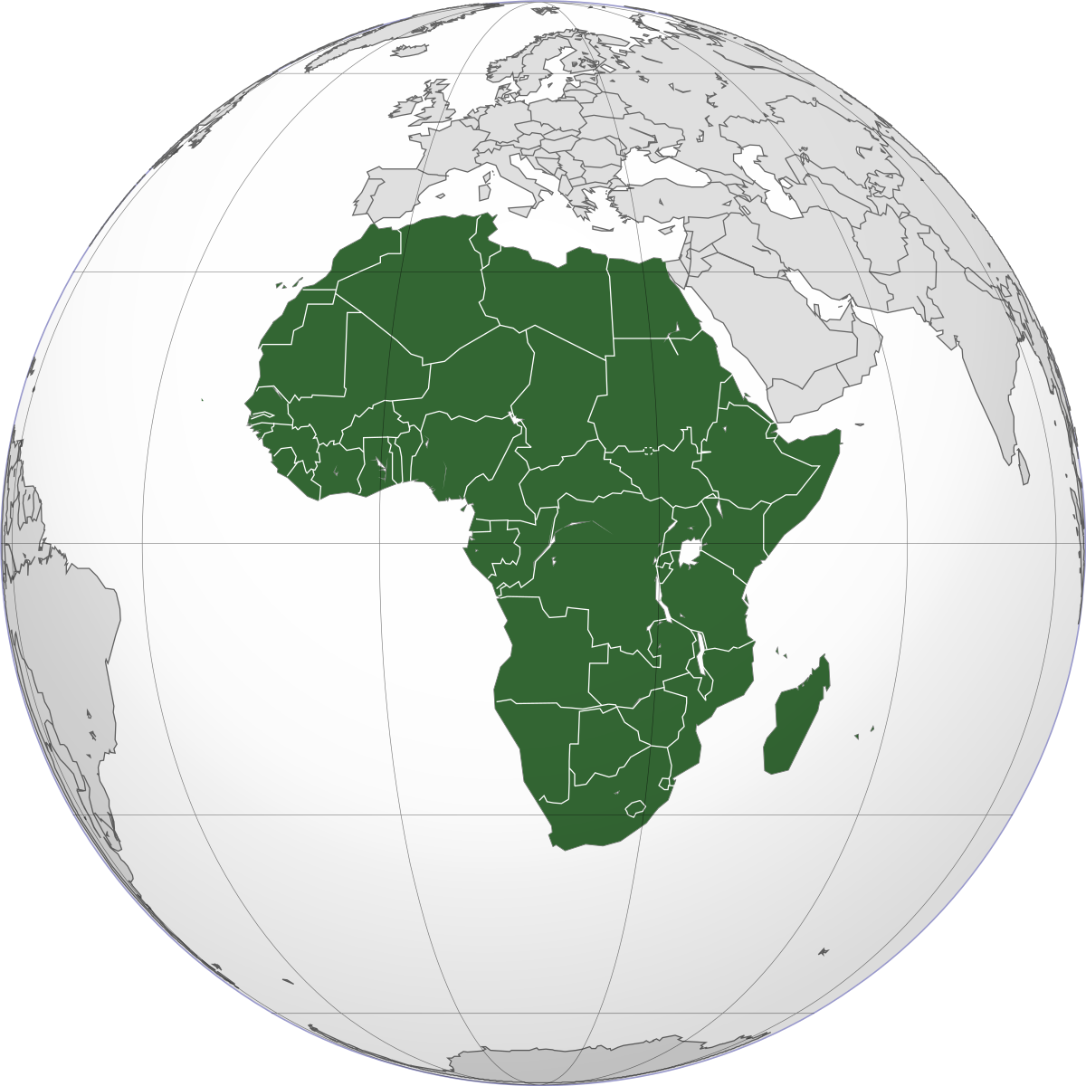

By Kenny & Chris

Contents

Contents 2
List of Tables 3
List of Figures 3
Summary 4
Introduction 4
Specify Sidecar 5
Specify Major Subsystems 6
Specify Criteria 6
Select Enclosure 7
Enclosure Types 7
Criteria Matrix Enclosure Type 8
Conclusion 8
Select Fastening 9
Fastening Types 9
Criteria Matrix Fastening Method 10
Conclusion 11
Select Axle 11
Axle Types 12
Criteria Matrix Axle Criteria 13
Conclusion 13
Select Wheel 13
Wheel Types 14
Criteria Matrix Wheel Type 14
Conclusion 14
Select Suspension 15
Suspension Types 15
Criteria Matrix Suspension Type 16
Conclusion 16
Actuation Method 16
Membrane and Fasteners 16
Axle/Wheel/Suspension 17
Concept Evaluation 18
Assembly 20
Sidecar Frame Membrane Assembly 20
Axle/Wheel/Suspension Assembly 20
Bike and Sidecar Suspension Assembly 20
Reference 21
Appendix 22
Subassembly 22
Bottom View 22

List of Tables
Table 1 Enclosure Type 7
Table 2 Criteria Score Table 8
Table 3 Fastening Methods 9
Table 4 Criteria Matrix Section Fastening Type 10
Table 5 Axle Types 12
Table 6 Criteria Matrix Axle Selection 13
Table 7 Wheel Type 14
Table 8 Criteria Matrix Wheel Type Selection 14
Table 9 Suspension Types 15
Table 10 Criteria Matrix Suspension Type 16
Table 11 Final Score Matrix Criteria 18
Table 12 Sidecar Frame Membrane Assembly 20
Table 13 Axle/Wheel/Suspension Assembly 20
Table 14 Bike and Sidecar Suspension Assembly 20

List of Figures
Figure 1 Process 4
Figure 2 African Ambulance Initial Concept 5
Figure 3 Major Subsystems 6
Figure 4 Sidecar Types 7
Figure 5 Membrane 8
Figure 6 Fastening Methods 9
Figure 7 Axle Types 11
Figure 8 Wheel Types 13
Figure 9 Suspension Type 15
Figure 10 Sidecar Frame & Membrane 17
Figure 11 Axle/Suspension/Wheel Assembly 17
Figure 12 Front & Rear View 18
Figure 13 Concept Views 18
Figure 14 Concept Evaluation Matrix 19
Figure 15 Subassembly 22
Figure 16 Bottom View 22

Summary

To correctly select components that contribute towards the design of the Sidecar using research and Criteria Matrix scoring tables. Breaking The attributes down into easier to manage subsections and conclude the outcome of each subsection. Combine all of the attributes selected by using a final Pugh Matrix Score Table which hopefully gives a (yes) conclusion to which the design concept should progress towards manufacture. An assembly method follows including suspension to Sidecar and Sidecar to bike.

Introduction

The initial report prior to this declares the frame of the Sidecar will be welded using aluminium box sections frame. The membrane fitted to the frame/chassis is made from a waterproof plastic material, the same as a tarpaulin. The membrane is designed to protect against the weather and environment. The initial attachment of the membrane is done so by using Velcro straps wrapped around the frame and tech screws with washers securing the membrane firmly in place. The base of the membrane is stapled to the plyboard that covers the aluminium frame.

This report details the outcomes and methods of component selection regarding the Sidecar. It specifies all attributes which include the Sidecar style regarding enclosure methods which are critically analysed using selection techniques and research. The fastening method of the membrane will be determined, and the actuation process will be described. A suitable axle will then be selected using research followed by a Criteria Matrix table with a conclusion. The outcome will dictate the wheel selection and suspension type to which the actuation of these components will be discussed and critically analysed again using research and Criteria Matrix tables. Once all attributes are selected they will be compiled together and followed by the assembly process to which shows the order to which components are mounted to Sidecar and bike.

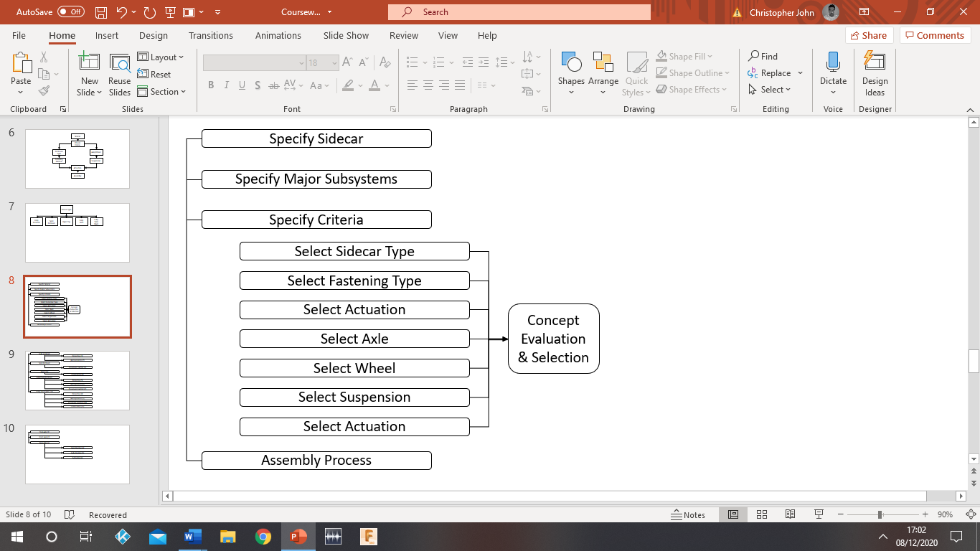
Figure 1 Process

Specify Sidecar

The initial design concept denoted as the African Ambulance sets the parameters of design. Already selected is the frame/chassis type being aluminium box section, which is to be welded and bolted together, and to the bike. A waterproof plastic membrane material has also been selected to counter weather and ingress. The membrane is to sit over the frame of the Sidecar and secured by means of Velcro straps and tech screws with washers. The base of the membrane is to be stapled to the plyboard. What has not been justified is the membranes cover type. For example, is the membrane to cover the whole Sidecar or can sections be removed? If sections can be removed what fastening method would be used to do so? Once the membrane has been resolved the selection of wheel, axle and suspension system will be justified.
- Select Membrane cover type
- Select Fasten method
- Select the appropriate axle
- Select appropriate wheel type
- Select the appropriate suspension
- Select actuation methods
- Assembly of components

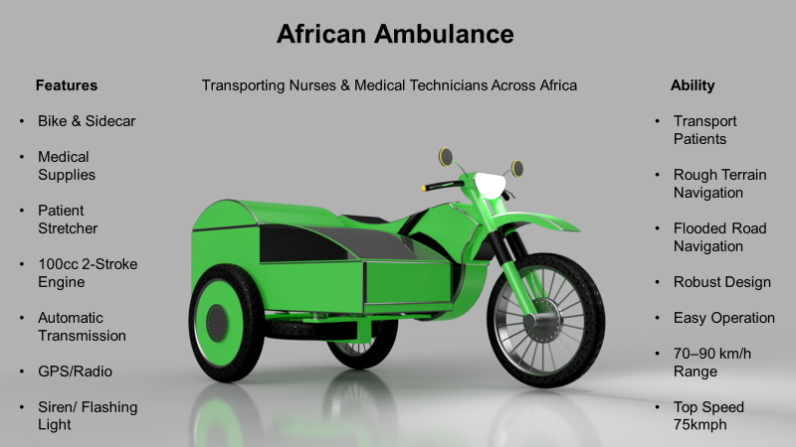
Figure 2 African Ambulance Initial Concept

Specify Major Subsystems

Major attributes are summarised using an objective tree, this method simplifies the requirements whilst showing the order of approach.
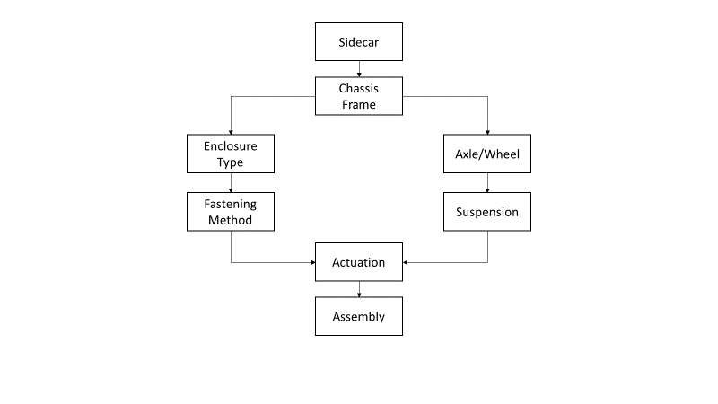
Figure 3 Major Subsystems

Specify Criteria

the customer has asked Chop & Swop to come up with some alternative design solutions for the Sidecar regarding weather protection of the passenger, aerodynamics and user-friendly ability. To help solve the customers’ demands five alternative design solutions have been selected.

Select Enclosure

. 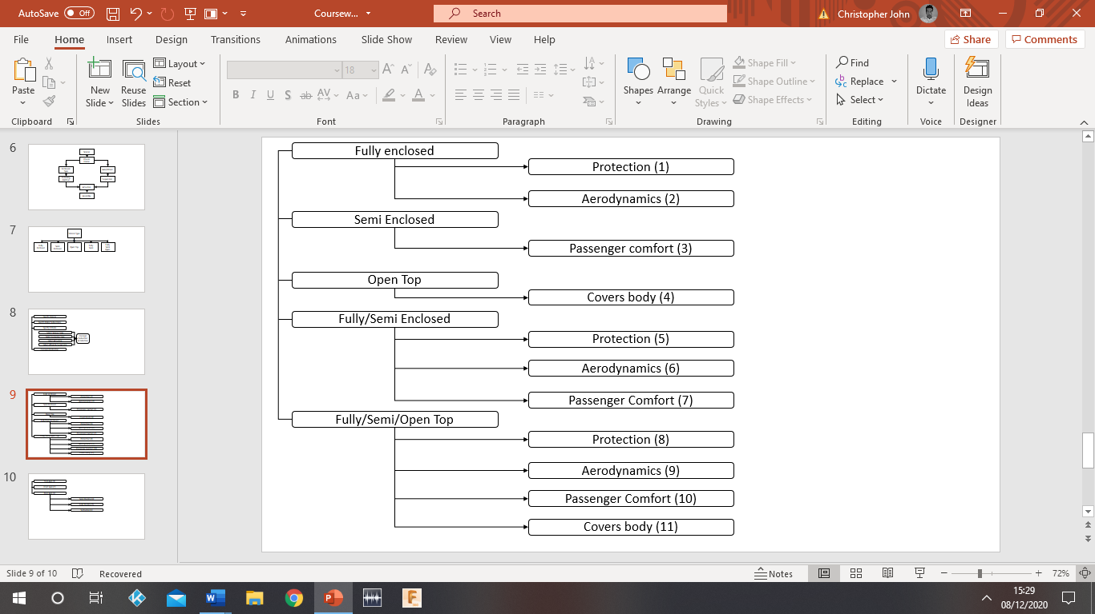
Figure 4 Sidecar Types

Enclosure Types
Select a suitable enclosure method, listed below are solution types.
Table 1 Enclosure Type
1  2 | Fully Enclosed Membrane  Providing protection from falling objects and protecting against rain and dust.  Aerodynamically sound when driving at speed.
3 | Semi Enclosed Membrane  Passenger comfort, heat control.
4 | Open Top Membrane  Covers the body but not the head as a safety helmet is supplied.
5  6  7 | Fully & Semi Enclosed Membrane  Providing protection from falling objects and protecting against rain and dust.  Aerodynamically sound when driving at speed.  For passenger comfort heat control.
8  9  10  11 | Fully, Semi & Open Membrane  providing protection from falling objects and protecting against rain and dust.  Aerodynamically sound when driving at speed.  Passenger comfort, heat control.  Covers the body but not the head as a safety helmet is supplied.

Criteria Matrix Enclosure Type
The Criteria Matrix Table helps select the Enclosure Method.
Table 2 Criteria Score Table
Criteria Rating 1-5 | Fully  Enclosed | Semi Enclosed | Open Top | Fully/Semi  Enclosed | Fully  Semi  Open
Passenger Comfort | 5 | 4 | 3 | 5 | 5
Weather Protection | 5 | 4 | 1 | 5 | 5
Aerodynamics | 5 | 3 | 1 | 5 | 5
Practicality | 4 | 3 | 1 | 4 | 5
Safety | 5 | 4 | 2 | 5 | 5
Total Score | 24 | 18 | 8 | 24 | 25

Conclusion
It has been decided that the Sidecar should have the ability to be fully enclosed, semi enclosed and open top to meet customer requirements. This means the membrane needs to have removeable sections.
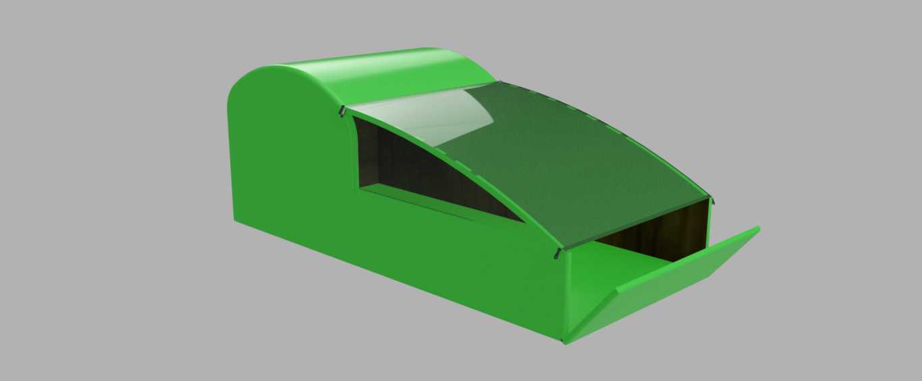
Figure 5 Membrane

Select Fastening

To incorporate a robust membrane with removable sections, five different methods of fastening the membrane have been selected.
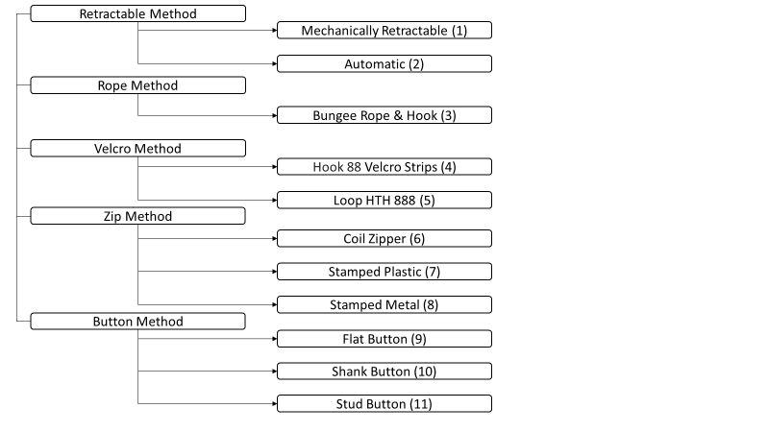
Figure 6 Fastening Methods

Fastening Types
Select a suitable fastening method, listed below are solution types.
Table 3 Fastening Methods
1 | Mechanically Retractable: Membrane works like a roller shutter door; you pull it out from its start position and fasten a hook to the end of the Sidecar. It needs a channel to slide across to operate.
2 | Automatic Reattraction: Requires a small motor to operate, it is not cost effective or practical, but easy to use.  (Roller shutter Anatomy: learn how roller shutters work, 2020)
3 | Bungee Rope & Hook: To tie down membrane sections is a good option. Utilizing a hooking system that attaches to the frame of the Sidecar.  (Tarpaulin Usage | Advice on Fixing a Tarpaulin in Place | How to Secure a Tarpaulin, 2020)
4 | Hook 88: Type Velcro strips can be sown onto the membrane and either glued using strong adhesive or bolted to the frame using a pattress. The weakness is under acceleration of the bike wind my get under the membrane and either tear or rip it off. It is not a secure method as Velcro is easily removable.
5 | Loop HTH: Method for Velcro is more secure than the strip version as it wraps around the frame several times rather than a flat surface to surface method the Hook type uses. It has a better fastening method and separating the surface contacts when loop is difficult. (Types, 2020)
6 | Coil: Zippers are lightweight ,the teeth are made of coiled nylon or polyester which is either sown, stitched or woven onto backing tape which is then stitched onto the membrane. The coil design makes it durable, the way it is constructed makes it very flexible. Coil zips are a good method to secure bags and jackets but are not used for heavy duty or force induced applications.
7 | Stamped Plastic: Is the weaker method of the three types, under force of acceleration it may be ripped from the zip rather than the membrane meaning this is the weak part and therefore not practical.
8 | Stamped Metal: Zippers are clamped onto the zipper tape. Design for heavy duty applications. Metal zippers are durable but heavier than plastic and nylon comparisons and tend to stick, also as it is being used outdoor induces rust. (Do it better yourself, 2020)
9 | Flat Buttons: Are a common method of fastening items together, they come in a wide range of choices from metal to plastic using an eye fasten technique.
10 | Shank buttons: Look like a ring with an over-sized diamond in them. They stand proud of fabric and can look out of place when used on a thin fabric, in this case the thin fabric is the membrane.
11 | Stud buttons Are similar to shanks, the difference is instead of a hole they have a pin which is attached through fabrics or membranes securing the button in place. (What are the different types of buttons and fastenings? | LoveCrafts, 2020)

Criteria Matrix Fastening Method
In order to select a section fastening type a Criteria Matrix Table will be used to identify the best method using environmental impact.
Table 4 Criteria Matrix Section Fastening Type
Criteria  Rating 1-5 | Retractable | Bungee | Velcro Loop | Metal Zip | Metal Shank
Robust | 2 | 4 | 2 | 5 | 3
Safety | 3 | 3 | 2 | 5 | 3
Aerodynamics | 3 | 3 | 2 | 5 | 2
Practicality | 4 | 2 | 4 | 5 | 4
Rust Proof | 1 | 5 | 5 | 2 | 2
Total Score | 13 | 17 | 15 | 22 | 14

Conclusion
A retractable membrane rather than an automatic version would be cost effective and lighter (1-2). The bungee method is used for tying down tarpaulins and protects against weather effectively (3). The Loop method is more secure than the strip version (4-5). A stamped metal zip is the best option, it is stronger and more durable when compared to coil and plastic type. (6-7-8). A metal shank is much stronger than a stud and flat button (9-10-11).
The metal zip is the better option, it has the ability to zip and unzip sections with ease, it outperforms every other method. The aerodynamics are uncompromised using a zipping method; however, rust may be a problem but will be overlooked due to African climate.

Select Axle

With Sidecar frame and membrane complete the axle will be fitted/mounted to the chassis by way of bolts and welds. What needs to be justified is the type of axle. Considering the bike is rear wheel drive an axle may be adapted to suit criteria.
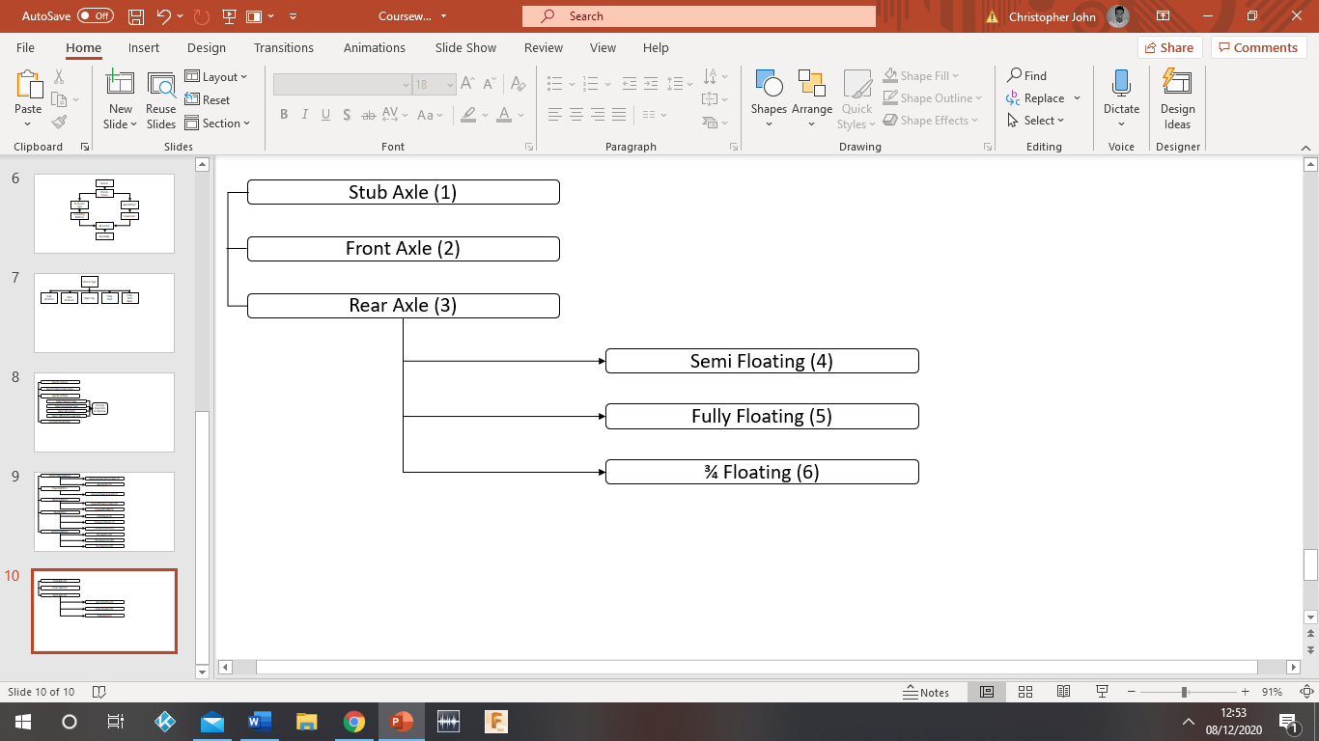
Figure 7 Axle Types

Axle Types
Selecting the right Axle is critical to design.
Table 5 Axle Types
1 | Stub Axle: Stub axles attach to a vehicle's front wheels and steering arm using kingpins connected to brackets either wielded or bolted to the front axle.
2 | Front Axle: Are situated at the front of a vehicle they incorporate four main components, the stub axle, swivel pin, track rod and beam. Front axles need to be strong, so the material selected is often either nickel-based alloys or carbon steel. Front axles help assist steering and absorb shock rough terrain.
3 | Rear Axles: Rear axles can be live or dead, live meaning they rotate, dead means they do not. If a dead axle is preferred then it needs bearings to stop the rotation. They deliver power to the drive wheels via a differential and come in two equal parts and often referred to as the half shafts.
4 | Semi-Floating Axle: This type of rear axle is designed for smaller vehicles; it is a dead type as it requires bearing support therefore the shaft has to be bigger than a front axle. Bearing one is situated within the axle and bearing two supports the axle. The semi axle connects the wheel to the flange and holds it in place.
5 | Full-Floating Axle: This axle type is also dead as it maintains its position using bearings, it is used for towing and large vehicles. More often than not used for four-wheel drive. This axle is designed to transmit torque and called a full floating axle as that is what it appears to do.
6 | ¾ Floating Axle: This axle type is helps align wheels, combats side thrust and torque. It is complex in design when compared to full or semi floating axles, however the complex engineering means it always performs.
(Types of Axles: Everything You Need to Know, 2020)

Criteria Matrix Axle Criteria
The Criteria Matrix tool enables selection of Axle type.
Table 6 Criteria Matrix Axle Selection
Criteria Rating 1-5 | Stub | Front | Rear Semi Floating | Rear Full Floating | Rear 3/4 Floating
Dead | 5 | 5 | 5 | 5 | 5
Live | 1 | 1 | 5 | 5 | 5
Reliability | 1 | 1 | 4 | 4 | 5
Strain Relief 100cc Engine | 5 | 5 | 5 | 4 | 4
weight | 5 | 1 | 3 | 2 | 1
Total Score | 17 | 13 | 22 | 20 | 20

Conclusion
The Stub and Front Axle are irrelevant methods as a rear wheel axle is required for the bike and Sidecar. A dead Semi Floating Axle is the preferred choice. A live axle would add extra work done by the 100cc engine rotating the mass of the axle. To counter rotation, two bearings are utilised. This axle method supports the weight of the chassis and enables alignment between the rear wheel of the bike and Sidecar wheel. The Semi Floating Axle is also lighter when compared with a Fully Floating Axle which is designed for larger vehicles. The ¾ Floating Axle is even heavier due to its complex design method even though it is more reliable than all the axle methods, weight is the biggest issue to overcome.

Select Wheel

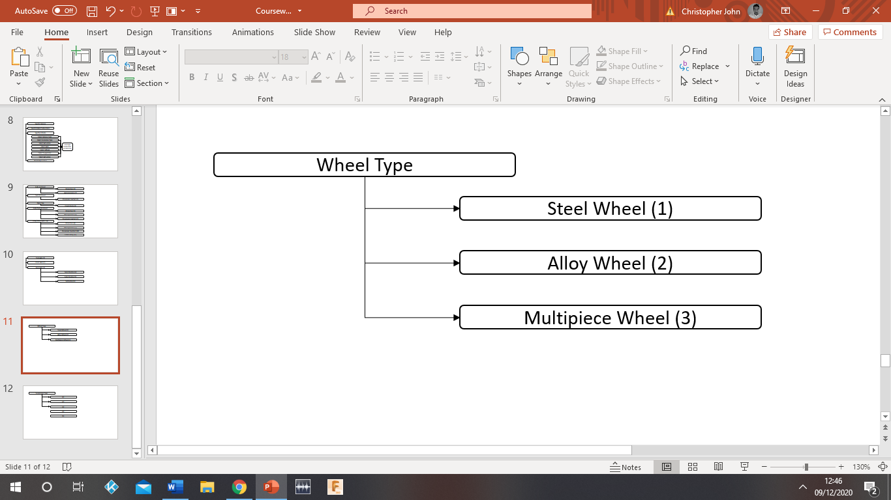
Figure 8 Wheel Types

Wheel Types
Select a suitable Wheel type, it must be strong and lightweight, listed below are solution types.
Table 7 Wheel Type
1 | Steel wheels: Are strong but with strength comes an issue with weight, these wheels are durable and were standard practice before alloys were available. Once alloy established itself as a lightweight version with similar strength the manufacture picked up and it soon became cheaper to produce an alloy wheel than a steel wheel. Rust is also a problem with steel wheels.
2 | Alloys Wheels: Are made from a combination of metallic materials, aluminium, magnesium and nickel. The combination or maraging of metals makes a material much stronger than a single material. Alloys are lighter than steel and retain strength. They are also rust resistant and cheaper to manufacture than steel. It is the most common type of wheel for vehicles although they are not as durable as steel wheels.
3 | Multipiece Wheels: Can be either steel or alloy. They are constructed using two or three parts fastened together using screws and sealants. This method reduces strength but allows for easy repair services whereas steel and alloy breakdowns require replacement of the whole wheel.
(Different Wheel Types And How They're Manufactured, 2020)

Criteria Matrix Wheel Type
The Criteria Matrix helps determine a suitable wheel for the Sidecar.
Table 8 Criteria Matrix Wheel Type Selection
Criteria  Rating 1-5 | Steel | Alloy | Multi Piece
Strength | 5 | 4 | 3
Cost | 3 | 4 | 2
Weight | 2 | 5 | 4
Rust | 2 | 4 | 3
Reliability | 4 | 4 | 3
Total Score | 16 | 21 | 15

Conclusion
Alloy is the best option, it is cheaper to produce than steel and multipiece, it has good strength to weight ratio increasing speed of the African Ambulance. It has better rust resistant than a steel wheel and just as reliable. The steel wheel has better strength however the weight is increased due to materials, and rust is a problem especially as the vehicle is to navigate flooded roads. Multipiece can be made from either steel or alloy, or the combination of both. However, it is weaker due to two or three parts being assembled and it requires more work to manufacture, therefore more expensive.

Select Suspension

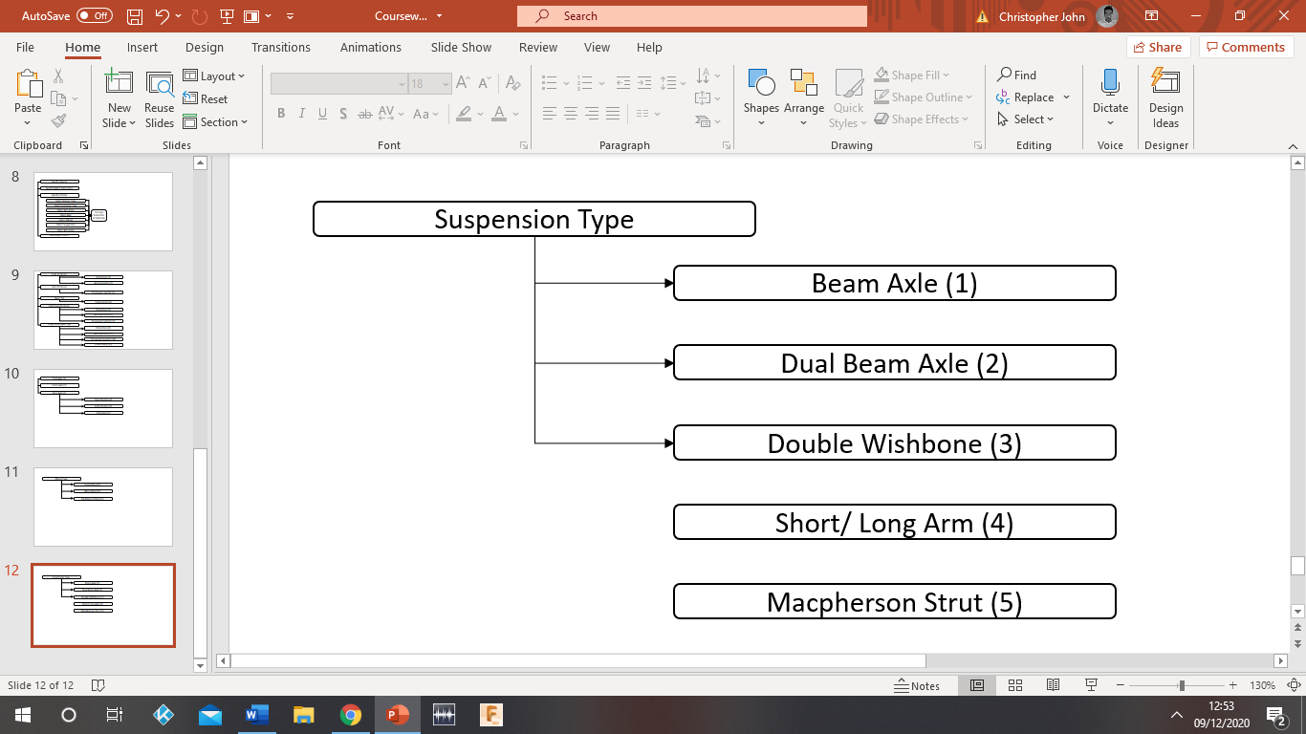
Figure 9 Suspension Type

Suspension Types
Select a suitable suspension method, listed below are solution types.
Table 9 Suspension Types
1 | Beam Axle: This a strong suspension system ideal for large vehicles, it has good tire contact under load and operates as a dependant suspension system. This means the wheels are connected in such a way that a bump over one wheel is felt on the other wheel.
2 | Dual Beam Axle: Has less contact with the road as its counterpart but it is strong and built for mid-size vehicles. It is an independent suspension system meaning the wheels are not connected and lumps and bumps felt do not transfer to other wheels. It is heavier due to it being dual axle and is mainly used at the front of a vehicle.
3 | Double Wishbone: This suspension system is lighter compared with beam axles but costs more, it is also independent and maintains a good tyre contact. This type is good for passenger carrying vehicles.
4 | Short/long Arm: This suspension system has good tyre contact and cornering capabilities in all conditions. Similar to the Double Wish Bone in many respects but lacks the camber ability. this type of suspension is designed for performance vehicles.
5 | Macpherson Strut: This type of suspension system has good tyre contact and cornering capabilities in all conditions. Similar to the Double Wish Bone and Short/Long Arm, but again, lacks the camber ability of the Double Wishbone. The benefit of this type of suspension is its layout, it has more room for adjoining drive shafts.
(Cedengineering.com, 2020)

Criteria Matrix Suspension Type
The Criteria Matrix helps determine a suitable suspension system for the Sidecar.
Table 10 Criteria Matrix Suspension Type
Criteria Rating 1-5 | Beam Axle | Dual beam Axle | Double Wishbone | Short/Long Arm | Macpherson Strut
Weight | 3 | 2 | 4 | 4 | 4
Independent | 0 | 5 | 5 | 5 | 5
Camber Angle | 1 | 1 | 4 | 3 | 3
Tyre Contact | 5 | 3 | 4 | 4 | 4
Rear Drive | 5 | 3 | 5 | 5 | 5
Total Score | 14 | 14 | 22 | 21 | 21

Conclusion
The Double Wishbone is the all-round better suspension system, it is an independent suspension system and has a good camber angle that can be closely controlled creating good tyre contact with the road whilst reducing wear and tear on the tyre. It is lite in weight and designed for carrying passengers. The Axle Beam is dependant which is no good for a Sidecar and bike setup, the Dual Beam is independent but heavier and lacks camber ability. The Long/Short Arm and Macpherson Strut are similar to the Double Wish Bone, but they do not have the camber ability.

Actuation Method

Membrane and Fasteners
It Has been justified that the enclosed/semi and open top method is most suitable, using metal zips to adjust membrane coverage. Aluminium box section is welded, plyboard is added to support the frame. The membrane is secured to the frame with Velcro straps and tech screws with washers. The membrane is then stappled to the plyboard base. The membrane covers the Sidecar complete, similar to how you would pitch a tent. Membrane sections can unzip and be removed depending on the environment. For example, see through plastic for window sections can be unzipped to allow air, or fully zipped to avoid dust and rain. Zips can be opened outside or from the inside, there are 8 zips in total and five additional sections. The drop-down panel gives access to passenger and patient; it is hinged at the bottom of the panel and uses swivel bolts to lock and unlock, making it simple and practical.

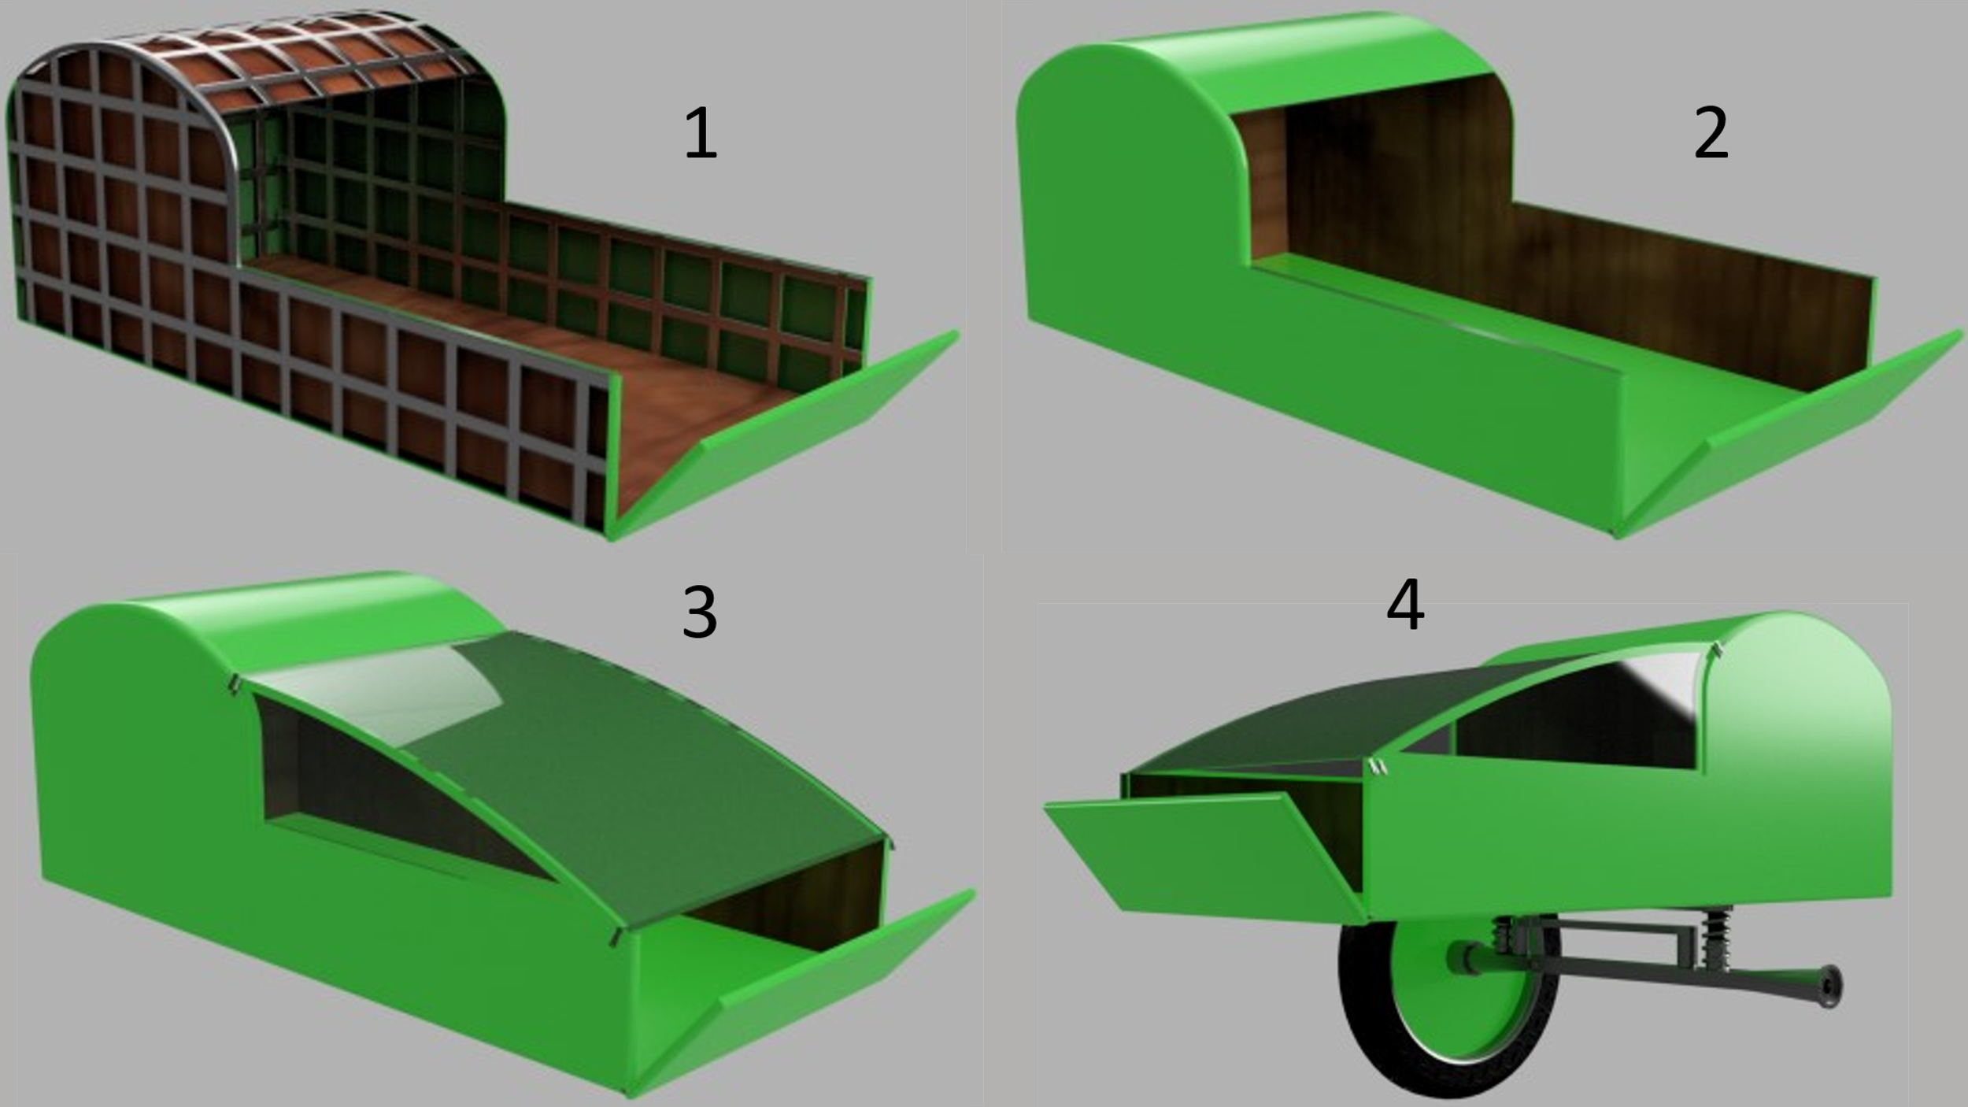
Figure 10 Sidecar Frame & Membrane

Axle/Wheel/Suspension
Semi Floating Dead Double Wishbone supports the chassis and Sidecar weight which also connects the alloy wheel of the Sidecar. Bearing supports at each end of the axle allow the Sidecar wheel to independently turn from the bikes rear drive. The Axle is attached to the bikes rear wheel support using bolts. The suspension system is a Double Wishbone type and solely operates the Sidecar wheel, giving the passenger a comfortable ride.
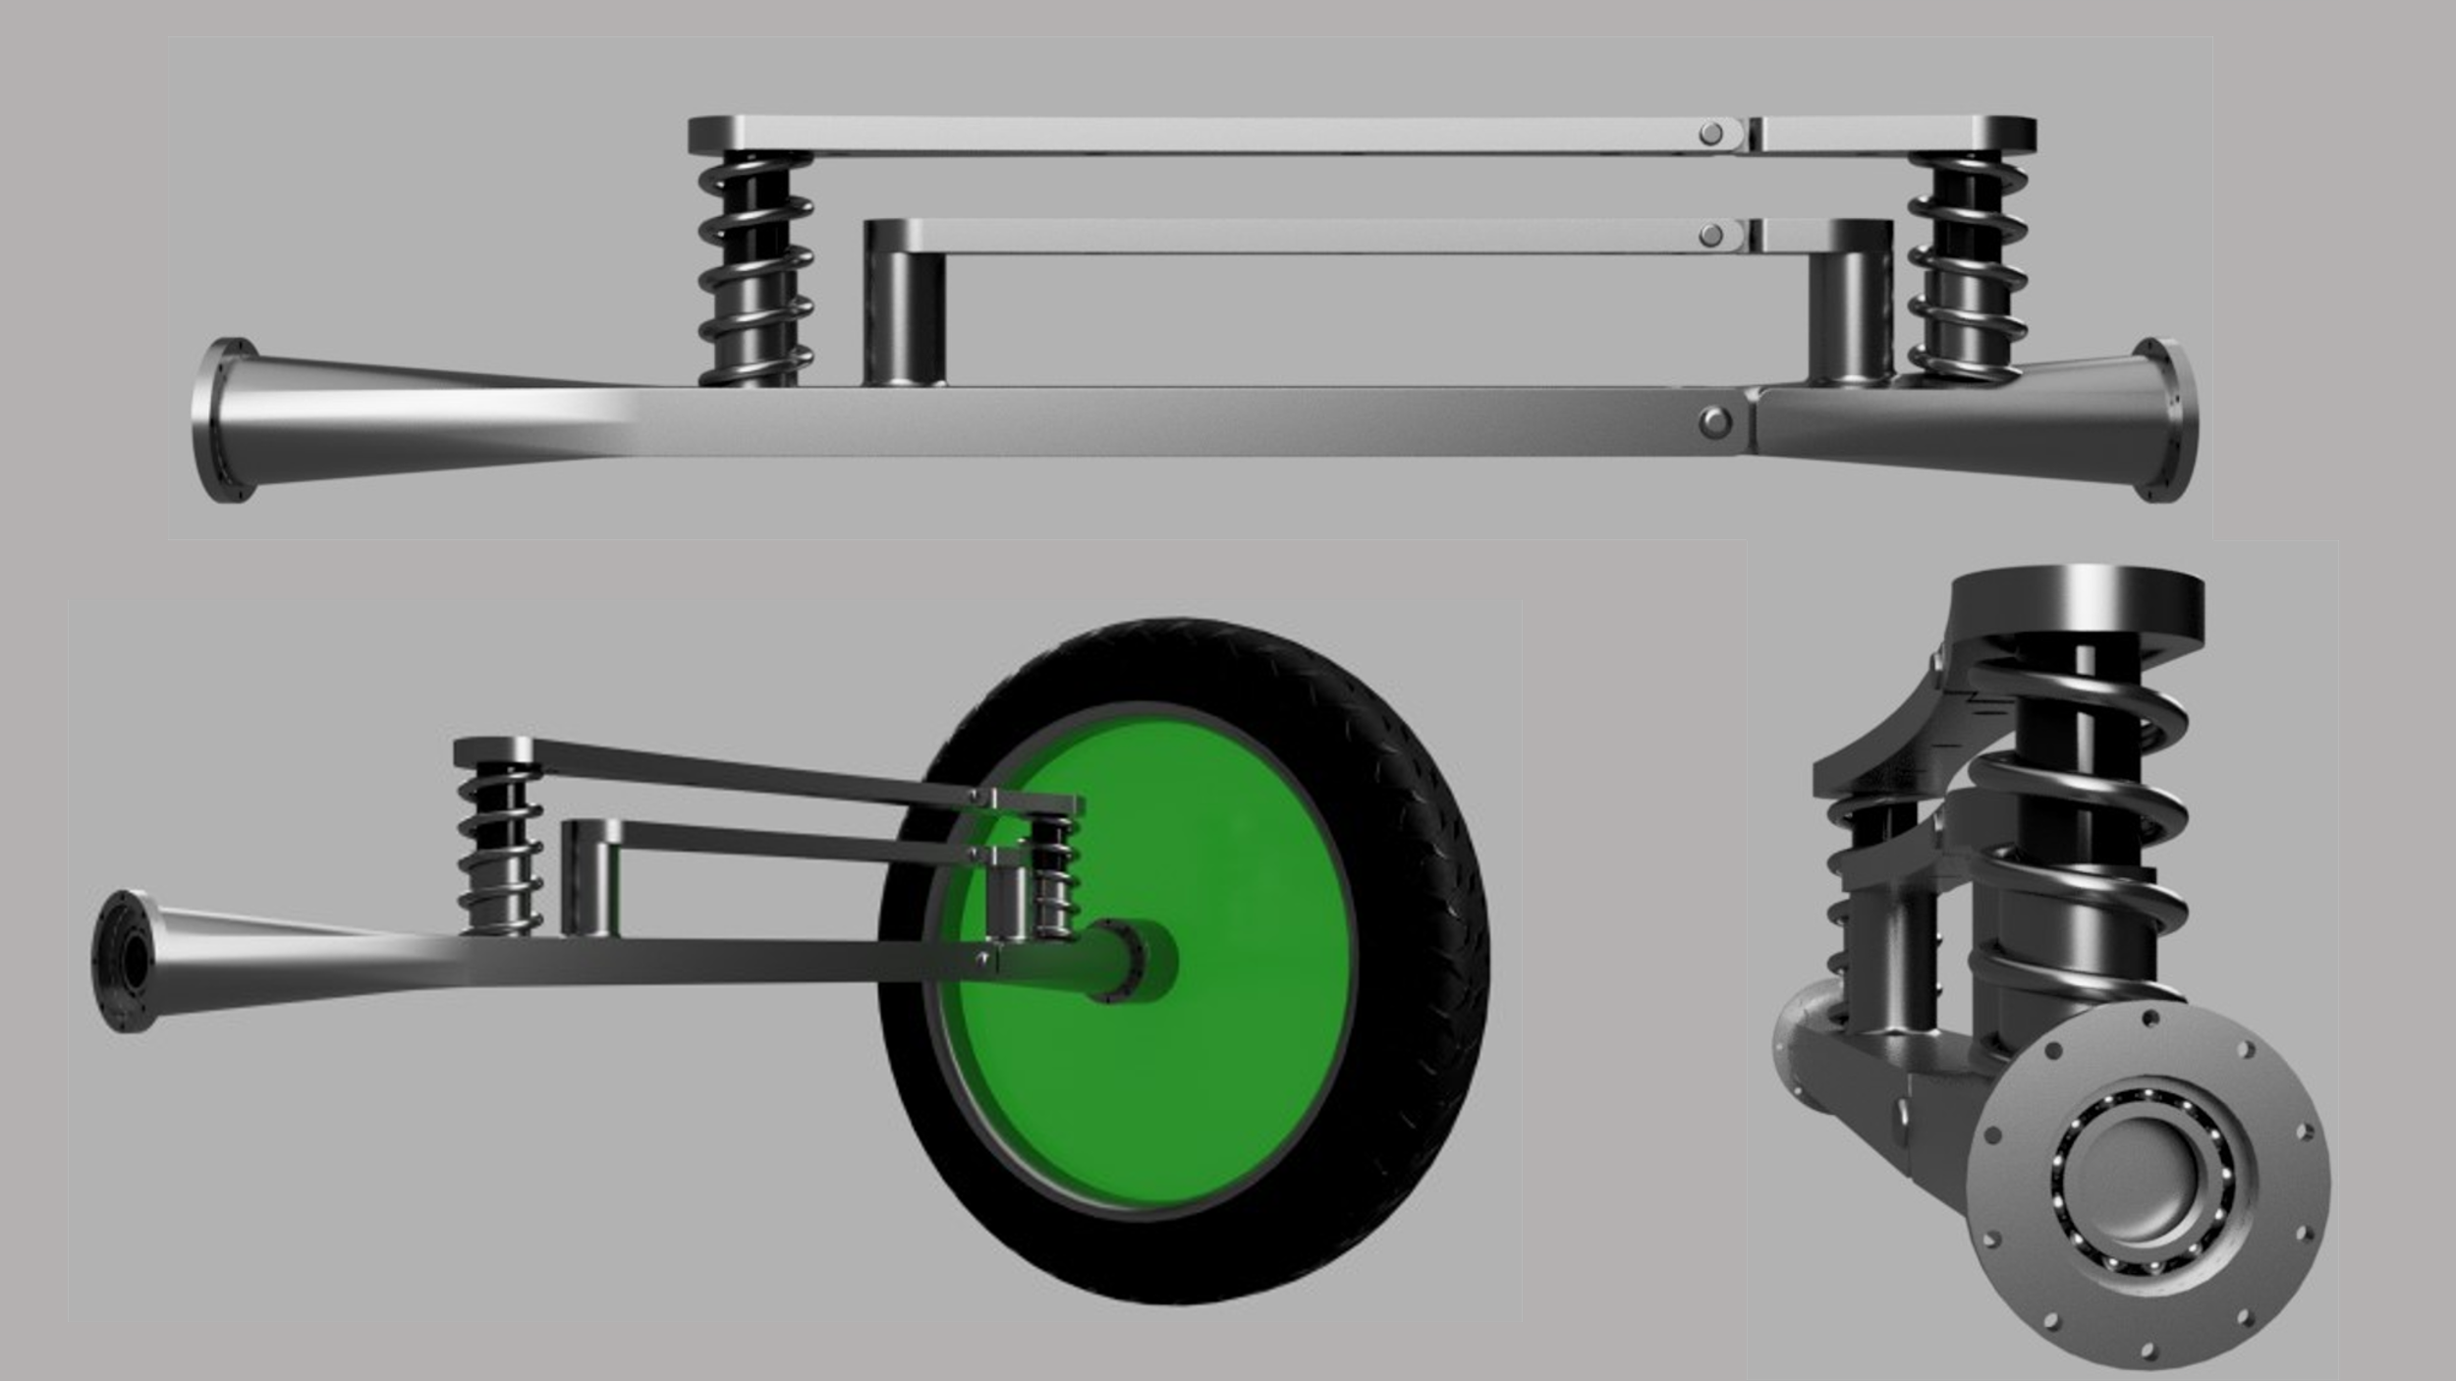
Figure 11 Axle/Suspension/Wheel Assembly

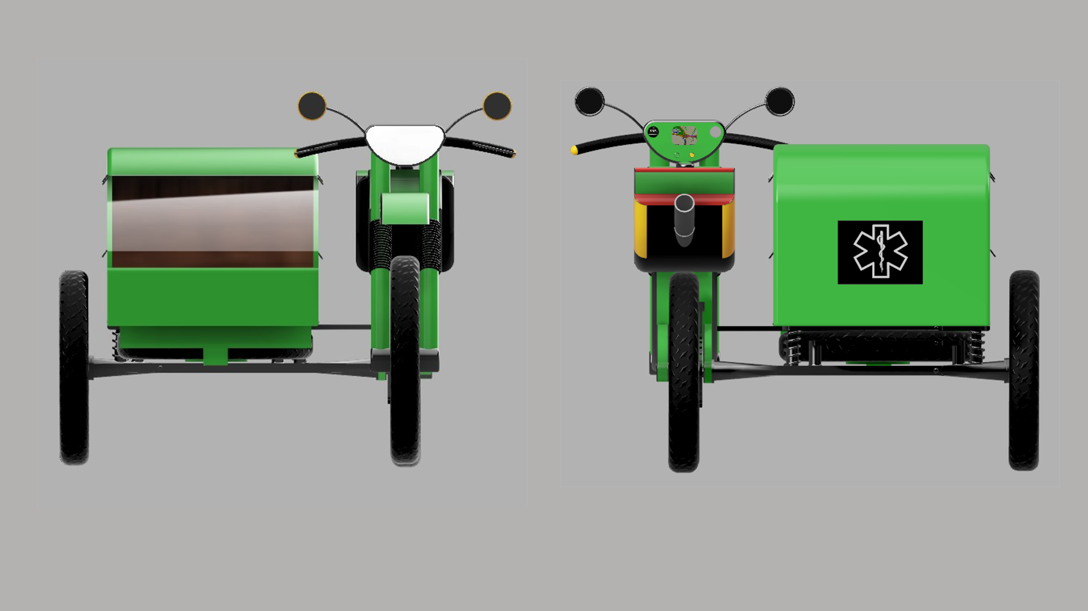
Figure 12 Front & Rear View
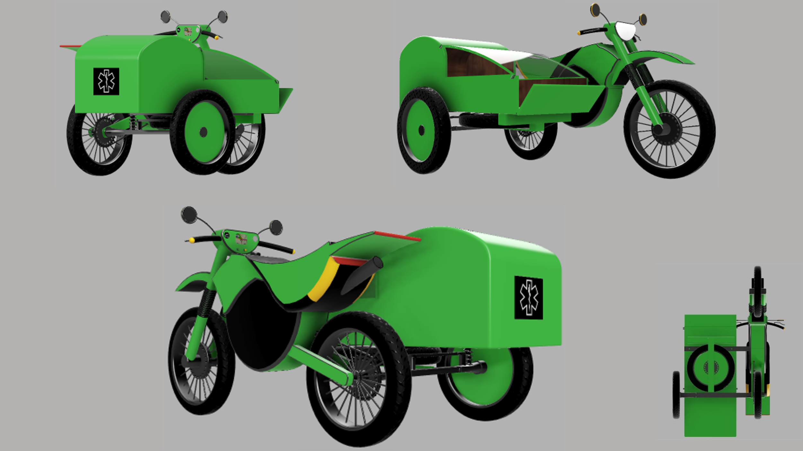
Figure 13 Concept Views

Concept Evaluation
Using Data from the five Criteria Matrix tables to conclude the final score Matrix. Items will be related to the Bike & Sidecar criteria, for example, environment and safety.
Table 11 Final Score Matrix Criteria
Concept A | Enclosure Method: Fully/Semi/Open Top
Concept B | Fastener type: Metal Zip
Concept C | Axle: Semi Floating
Concept D | Wheel: Alloy
Concept E | Suspension: Double Wishbone

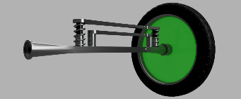
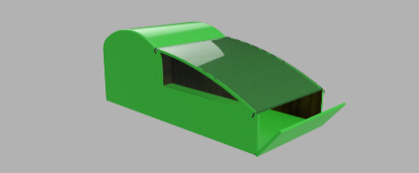
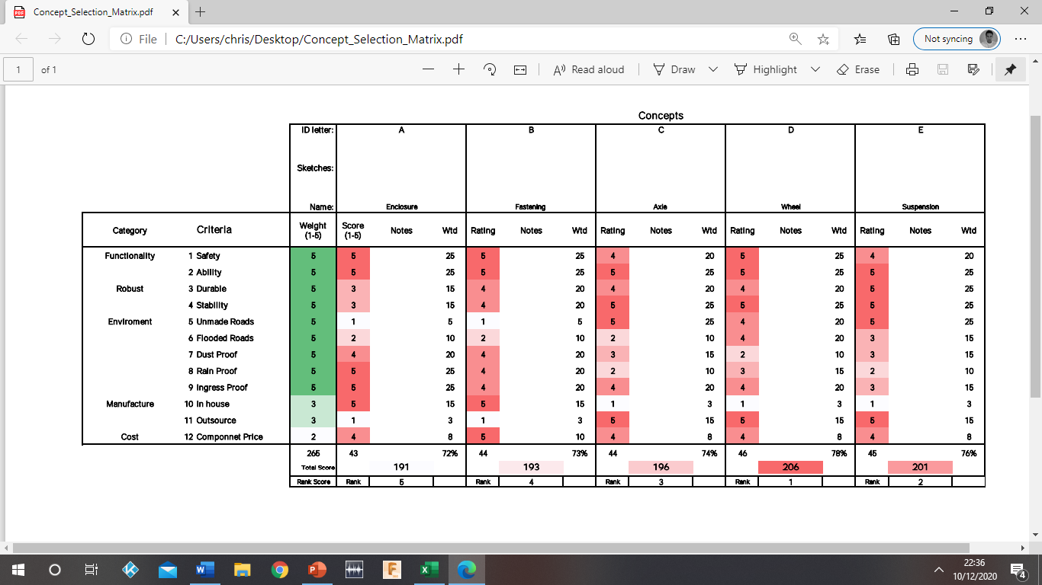
Figure 14 Concept Evaluation Matrix
The concept evaluation matrix combines all the vital components that make up the Sidecar, the criteria covers the functional aspects, environment, manufacture and cost. The problem with this type of chart is you compare criteria that is not relevant in some instances and this lowers the score/percentage, the outcome for all five components was a (MAYBE) when infact it is a (YES). However, even with irrelevant comparisons all components score over 70%. It is a valid concept and therefore should be implemented.

Assembly

Sidecar Frame Membrane Assembly
Table 12 Sidecar Frame Membrane Assembly
1 | Weld aluminium box section forming frame and chassis.
2 | Use tech screws & washes to fix plyboard to frame and chassis internally.
3 | Pull membrane over the frame and chassis.
4 | Use Velcro straps, tech screws & washers to secure membrane in place.
5 | Use tech screws to secure plyboard base.
6 | Cover plyboard base with membrane.
7 | Stapple the membrane to the plyboard.
8 | Fit drop-down panel for access using a hinged joint with locking bolt.
9 | Add zipped sections to membrane to cover exposed area.

Axle/Wheel/Suspension Assembly
Table 13 Axle/Wheel/Suspension Assembly
1 | Obtain the semi floating dead axle.
2 | Grease 2 x interference fit bearings.
3 | Add a bearing to each hollowed end section of the axle.
4 | Weld double wishbone to the axle facing the Sidecars wheel position.
5 | Use 4 x 10mm bolts and fixing plate to secure axle and wishbone.
6 | Position wheel to axle using the stub as a guide and support.
7 | Bolt Sidecar wheel to axle bearing using 8 x 5mm bolts.
8 | Check suspension system for damage or fractures.
9 | Grease all joints.

Bike and Sidecar Suspension Assembly
Table 14 Bike and Sidecar Suspension Assembly
1 | Align the suspension with the Sidecar.
2 | Bolt suspension to Sidecar chassis using 5 x 10mm bolts.
3 | Check alignment with rear of bike attachment.
4 | Use guide stub and bearing support of the bike to connect axle with bike.
5 | Use 8 x 5mm bolts to secure axle to bike.
6 | Check alignment and look for faults.
7 | Fix support arm to chassis using 4 x 10mm bolts.
8 | Align support arm with bikes protection cover.
9 | Bolt support arm to bikes protection cover.

Reference

Hvpshutters.co.uk. 2020. Roller Shutter Anatomy: Learn How Roller Shutters Work. [online] Available at: <https://www.hvpshutters.co.uk/anatomy-roller-shutter.php> [Accessed 11 December 2020].

Tarpaflex.co.uk. 2020. Tarpaulin Usage | Advice On Fixing A Tarpaulin In Place | How To Secure A Tarpaulin. [online] Available at: <http://www.tarpaflex.co.uk/acatalog/Tarpaulin-Advice.html> [Accessed 11 December 2020].

Types, V., 2020. VELCRO Brand Hook Types. [online] Itapestore.com. Available at: <https://www.itapestore.com/VELCRO-Brand-Hook-Types_ep_52-1.html> [Accessed 11 December 2020].

2020. [online] Available at: <https://doitbetteryourself.club/blog/understanding-zipper-types-weights-sizes-and-parts/> [Accessed 11 December 2020].

LoveCrafts. 2020. What Are The Different Types Of Buttons And Fastenings? | Lovecrafts. [online] Available at: <https://www.lovecrafts.com/en-gb/c/article/what-are-the-different-types-of-buttons-and-fastenings> [Accessed 11 December 2020].

Car and Driver. 2020. Types Of Axles: Everything You Need To Know. [online] Available at: <https://www.caranddriver.com/research/a31547001/types-of-axle/#:~:text=Axles%20are%20essential%20components%20of,front%2C%20rear%2C%20and%20stub.> [Accessed 11 December 2020].

Car Throttle. 2020. Different Wheel Types And How They're Manufactured. [online] Available at: <https://www.carthrottle.com/post/different-wheel-types-and-how-theyre-manufactured/> [Accessed 11 December 2020].

Cedengineering.com. 2020. [online] Available at: <https://www.cedengineering.com/userfiles/Automotive%20Suspension%20Systems.pdf> [Accessed 11 December 2020].

Appendix

Subassembly
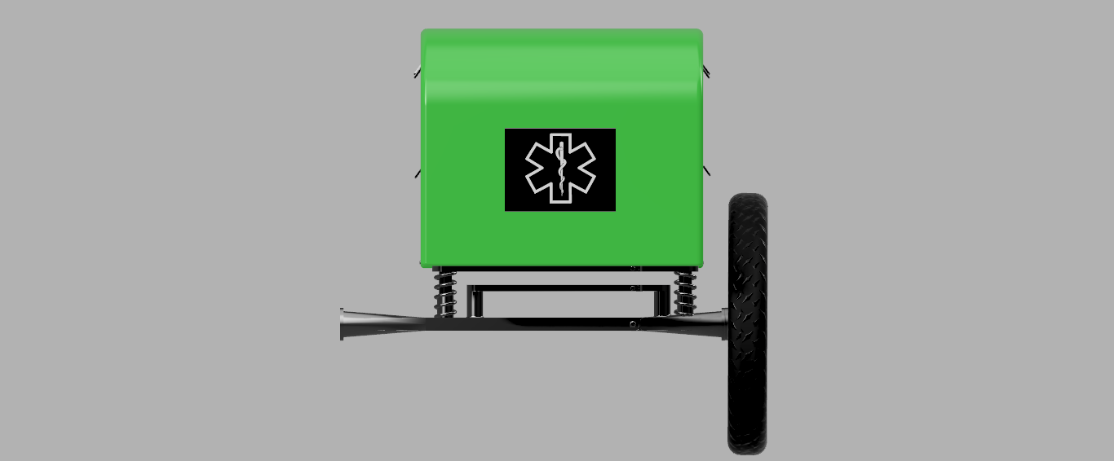
Figure 15 Subassembly

Bottom View
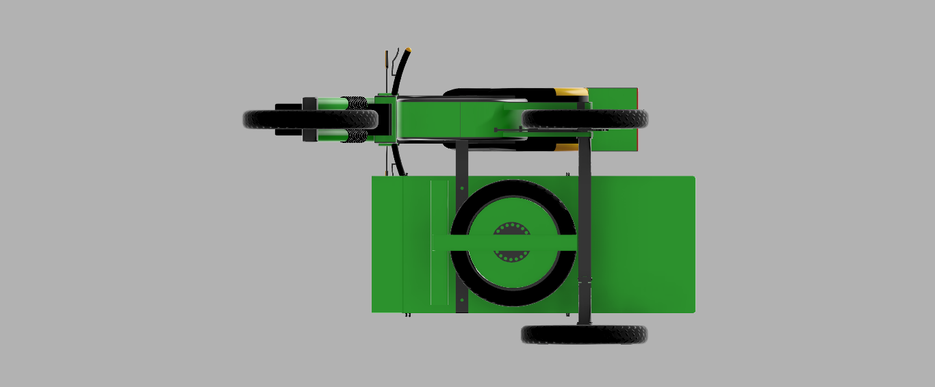
Figure 16 Bottom View

