**Carbon Monoxide Detector**

# **Contents**

**Carbon Monoxide Detector** 1

**Contents** 1

**Summary** 2

**Introduction** 2

**Statistics** 2

**Facts** 2

**Initial Thought** 3

**Unique Features** 3

**How It works** 3

**Function and Ability** 4

**Regulation** 4

**Alarm Receiving Centres (ARC)** 5

**Residents Details** 5

**Fire Brigade** 5

**Bluetooth** 5

**Alarm to Vibration Pads** 5

**Alarm to Onboard Wristband Vibrator** 5

**Manufacture/Prototype** 5

**Electrical Safety** 6

**Gas Network Perspective** 6

**Concept Design** 6

**Carbon Monoxide Detector** 6

**Wristband** 7

**Vibration Pad** 7

**Set up** 8

# **Summary**

This report is to Design/Innovate a Carbon Monoxide Detector/Alarm suitable for the hard of hearing and visually impaired. The report will also incorporate facts, regulations and solutions aiming to resolve the problem. The problem being that Audible Alarms are not compatible with the hard of hearing and visually impaired.

# **Introduction**

Carbon Monoxide (CO) is believed to be responsible for the deaths of around 50 people a year in the UK, while many more may have narrow escapes, as the symptoms of low-level Carbon Monoxide poisoning can be similar to the flu. Most of these deaths relate to the use of solid fuel appliances such as log burners, and this led to the UK government introducing new legislation in 2015 that required private landlords to install a working CO alarm in all rented properties that include solid fuel heating.

Currently mains powered Carbon Monoxide Detectors operate perfectly well regarding the able bodied. However, the hard of hearing and visually impaired struggle to benefit from this existing technology. So, an innovative solution is required.

This report will declare the best possible outcome in order to design and build a full proof Carbon Monoxide Detector that incorporates existing hard-wired smoke and heat detecting alarms whilst being monitored via an **Alarm Receiving Centre (ARC)**. This device is designed for the hard of hearing, visually impaired and the combination of both. An all in one inclusive unit that is universally versatile and thus cost effective.

## **Statistics**

* 11 million hard of hearing people reside in the UK
* 2 million visually impaired people reside in the Uk
* 400,000 hard of hearing and visually impaired people reside in the UK

## **Facts**

A total of 13.4 million people (1 in 5) could benefit from a revised Carbon Monoxide Detector that not only alerted of Carbon Monoxide poisoning but incorporated existing hard-wired smoke and heat alarms via interlinking. Thus, the whole premises could be monitored, this would depend on the vulnerability of an occupant. The monitored system contacts ARC, which also contacts the fire brigade, family member, guardian or carer when either Carbon Monoxide, Extreme Heat or Smoke arises within a domestic property.

## **Initial Thought**

The device is to be a mains powered (220V) Carbon Monoxide Detector with battery backup, with interlinked connections for heat and smoke detectors. It is to act like a standard mains operated CO detector, for example, Aico/Kidde and is to comply with current regulations. However, the difference is the interaction between detector and occupant and notification of ARC/Fire Brigade within a domestic dwelling. Vulnerable people require extra care and attention, this device is designed to safeguard and give vulnerable people the confidence to live a life with limited worry. Knowing that somebody will be there for you when it is needed makes all the difference in my opinion.

## **Unique Features**

The device shall be fitted with smart technology so when an alarm is triggered it alerts the occupant via 3 methods. ARC is contacted directly by triggering the alarm.

* Flashlight
* Vibration
* Sound
* ARC Monitored

# **How It works**

Once the device is installed it operates via the detection of Carbon Monoxide, this then triggers three versions of alarm.

* Sounder
* Flashlight
* Vibration

By interlinking existing smoke and heat detectors all audible alarms engage, the flashlight on the CO detector enacts, and the vibration pads fitted to bed, couch, chair and on-person wristband vibrator activate. This alerts the vulnerable person by either sound, light or vibration. If it is a false alarm they have two minutes to silence the alarm via wristband or detector. Failure to silence after two minutes automatically alerts ARC who summon the fire brigade to that property, ARC also alert the family member/guardian or carer.

Equally, if the smoke alarm or heat detector senses smoke or extreme heat the interlinking mechanism of devices triggers the Carbon Monoxide Detector this also contacts ARC.

Equipment and devices are to be routinely maintained/tested via a test switch positioned on the Carbon Monoxide Detector by either family member, guardian or carer once a week and the wristband vibrator should be checked for battery life and correct working at the same time.

# **Function and Ability**

1. The device shall be fitted with an LED flashlight, this operates when the devices detects CO and will visually alert an occupant who cannot hear the problem.
2. A test button for maintenance.
3. The device shall be fitted with a sounder, although the majority of occupants maybe hard of hearing it would still help notify neighbours whilst maintaining inclusive advantages for the visually impaired occupants.
4. The device will interact with wireless vibration devices such as vibration pads and on-person wristband vibrator either by Bluetooth or Wi-Fi connectivity.
5. If the alarm is false It will have to be answered within 2 minutes, failure to stop the alarm will automatically contact the fire brigade and family member to that address. (burnt toast)
6. Via research the fire brigade does not take kindly to false alarms and only make visits if a known fire/gas is detected. There is a fine if a false alarm has wasted their time.
7. The device will interact with existing heat and smoke detectors, after 2 minutes of activation ARC/Fire Brigade and family member will be contacted regarding either Carbon Monoxide, Extreme Heat or Smoke detection.
8. Premises with existing Carbon Monoxide, heat and smoke alarms shall be easily altered by replacing the Carbon Monoxide alarm with this new solution minimising work applications. For example, wiring and connectivity.
9. Under no circumstances is this device to be solely operated via batteries, only as a back-up.

# **Regulation**

* ISO 9001
* IEEE 802.15.1
* EN 50130-4
* EN 61000-6
* BS EN 60065
* BS 7671

To comply with relevant regulations.

# **Alarm Receiving Centres (ARC)**

## **Residents Details**

**Details of occupant shall be made available to ARC; they will contact both the fire brigade and member of the family/guardian/carer.**

## **Fire Brigade**

**Will receive information of the occupant via ARC with an immediate response.**

# **Bluetooth**

## **Alarm to Vibration Pads**

**Vibration Pads are to be hard wired using an unswitched fuse spur, so it cannot be disconnected. These pads will be designed for beds and couches/chair.**

## **Alarm to Onboard Wristband Vibrator**

* **Vibration wristband alerts the hard of hearing and the** visually impaired **directly. Charges via wireless passive charging socket.**
* **To be checked weekly via carer/family member.**
* **CO is detected via alarm, triggers smoke and heat detector sounders, triggers vibration pads/wristband and flashers. Sends a signal to ARC/Fire Brigade.**
* **Any interlinked detector within a domestic household will summon ARC/Fire Brigade via the CO detector after 2 minutes of activation.**

# **Manufacture/Prototype**

1. A 3D printed design will be the method of manufacture regarding housing of all equipment.
2. The Carbon Monoxide detection device shall be brought as existing technology.
3. Bluetooth/WI-FI connectivity shall be brought as existing technology.
4. Vibration pads housing will be 3D printed but the vibration device within will be brought via existing technology alongside inbuilt Bluetooth/WI-FI technology.
5. Electrical wiring connections shall be brought as existing technology.
6. The onboard wristband vibrator housing shall be 3D printed; however, power and Bluetooth connections will be brought via existing technologies.
7. Connecting the Carbon Monoxide Detector to ARC/Fire Brigade will need to be outsourced, this can be done via wireless connectivity but needs expert advice.
8. Unswitched fuse spurs shall be brought via electrical wholesaler to mains power vibration pads. And fitted by a competent person.

# **Electrical Safety**

Only competent people such as qualified electricians, gas and fire alarm engineers will be able to carry out the installation of the Carbon Monoxide Detector.

# **Gas Network Perspective**

From a gas networks perspective regarding the Carbon Monoxide Detector. This device gives a reassurance to the installer/maintenance that if there was ever a Carbon Monoxide leak regarding a boiler or gas fire, not only would an alarm be raised but an automatic response from the ARC would be made. Mistakes happen and faults can occur, it is one thing making a mistake but a whole other problem when someone’s life is in jeopardy due to Carbon Monoxide poisoning. This device would put peoples mind at rest from a vulnerable occupant to a gas engineer.

# **Concept Design**

## **Carbon Monoxide Detector**

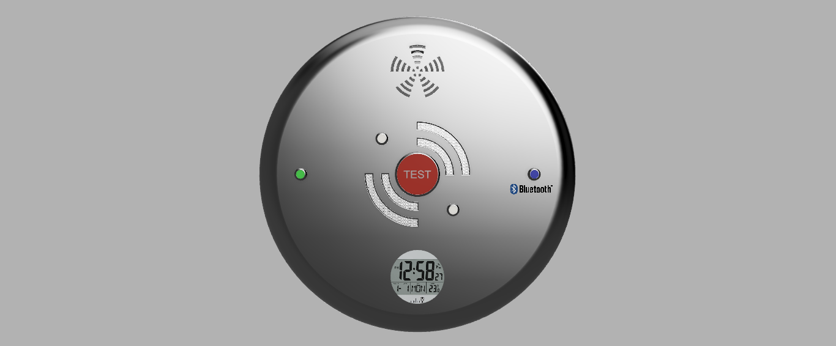

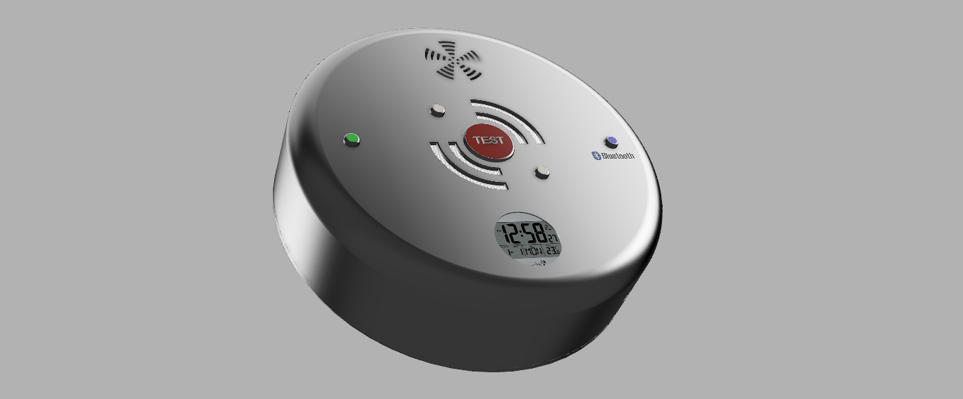

## **Wristband**

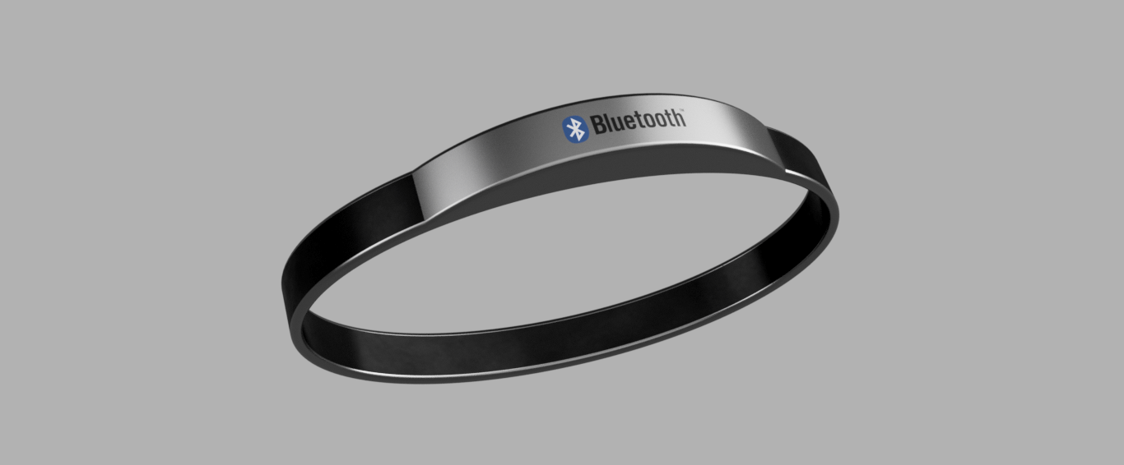

## **Vibration Pad**



## **Set up**

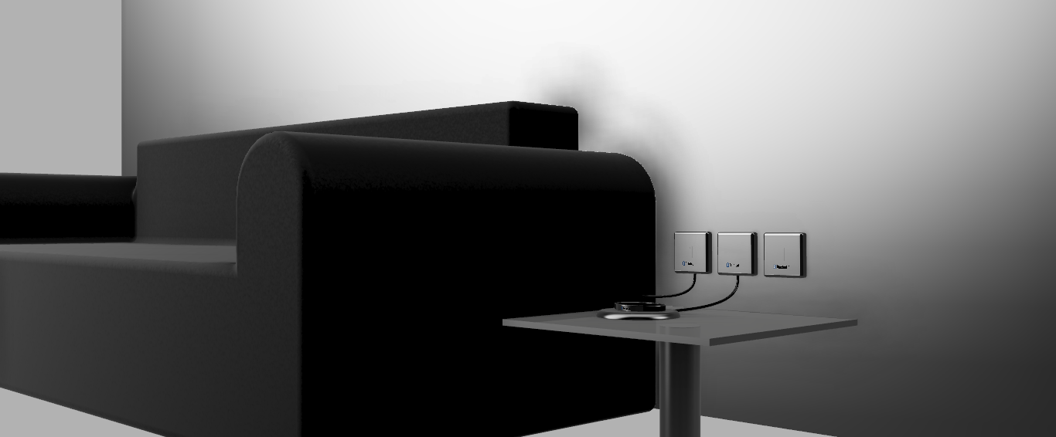

Two Spurs For hard wired supply to charge wristband and power vibration pad fitted in the couch, wristband either wireless charge or USB. ARC telephone point connected to phone line provider. All devices are Bluetooth and connect to Alarm. I am leaning more towards Bluetooth as opposed to WI-FI due to network failure.

