**Engineering Design Methods**

**Coursework 1**

**African Medical Transport**

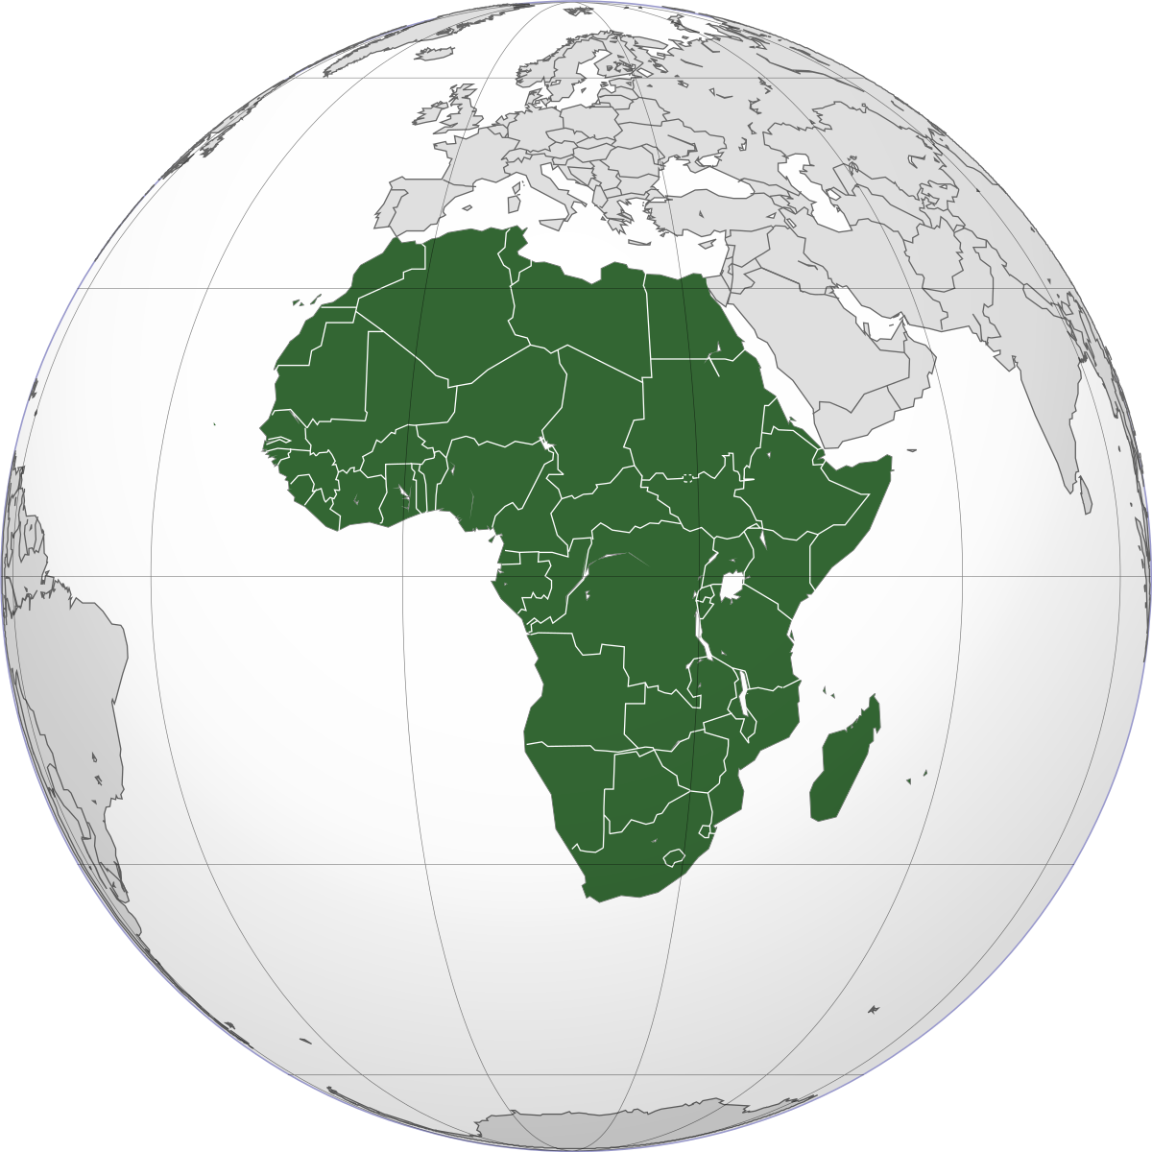

**By Kenny & Chris**

# **Contents**

Contents 2

List of Tables 3

List of Figures 3

Summary 4

Introduction 5

Customer Specification 5

Quality Function Deployment 6

Pugh Matrix 7

Customers Objective Tree 7

Quad Bike 8

100cc Engine 8

Automatic Transmission 8

Engineers Objective Tree 9

Design Teams’ Further Input 9

Problem with Sidecar 9

Additional Features 10

Customer Agreement 10

Product Design Specification 10

Brief 11

Specification 16

African Ambulance Features 20

Ability 20

Sidecar 20

Bike 20

Constraints 21

Weight 21

100cc engine 21

Conclusion 21

References 23

## **List of Tables**

Table 1 Customer Demands 5

Table 2 Pugh Matrix 7

Table 3 Manufacture Build 14

Table 4 Specification 16

## **List of Figures**

Figure 1 Project X 4

Figure 2 Requirement Objective Tree 5

Figure 3 Quality Function Deployment 6

Figure 4 Customer Objective Tree 8

Figure 5 Engineers Objective Tree 9

Figure 6 Design Method Objective Tree 10

Figure 7 African Medical Symbol 13

Figure 8 African Ambulance Features 20

Figure 9 African Ambulance 22

# **Summary**

To deliver a vehicle solution for a Charity organisation regarding transport issues for nurses and medical technicians in Africa. Using the charity organisations customer requirements to determine a vehicle type will be selected by using a Quality Function Deployment (QFD) chart. The data collected will determine a suitable method of transport. Once the data has been collected a simple Pugh Matrix chart an objective tree will be created for the benefit of the customer for their input on vehicle type. Upon agreement of the vehicle a complex objective tree is given to the designers showing the weighted balance and thought process behind the QFD decision making. Once everybody is happy with the outcome a Product Design Specification (PDS) will be formed. The PDS shows the specification of the vehicle to be implemented which includes the vehicles ability, features and how it works. Highlighting objectives and constraints with a final conclusion.

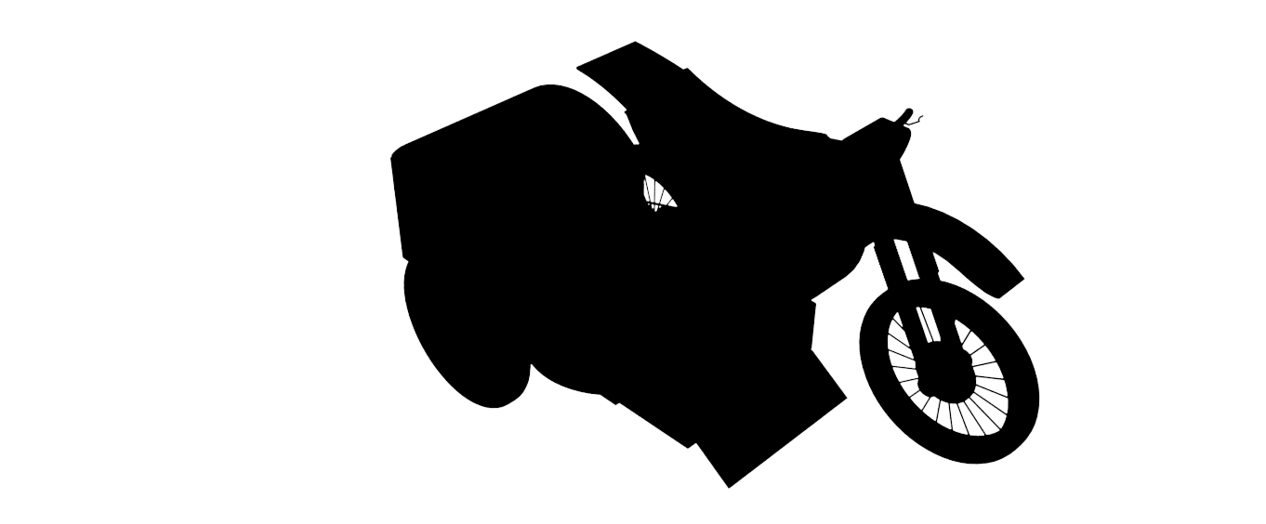

Figure 1 Project X

# **Introduction**

This report is based on providing a suitable transport vehicle for nurses and medical technicians in Africa. A charity organisation has approached our company “Chop & Swop” regarding terrain and flooded road issues encountered by medical staff. The charity has given a criteria to which we would be interested in meeting. A thorough investigation into the problem will be undertaken and concluded, hopefully providing a valid solution leading on to further innovative designs. The charity has contacted Chris and Kenny’s company “Chop & Swop” because they are aware the company put vehicles and accessories together that would not normally be. The company has a design team with great customer liaisons skills with an ability to understand the customers’ requirements, needs and demands in detail. Our moto is, “we know what the customer wants more than what the customer knows they want”.

# **Customer Specification**

The charitable organization has a specification in mind for a simple vehicle to provide transport for a nurse or medical technician in Africa. It must be stable and capable of carrying medical supplies or alternatively a patient on a simple stretcher. The vehicle must be powered by a 100cc scooter engine with automatic transmission. The transport vehicle must be stable and requires at least three wheels. The vehicle must be able to transverse rough, muddy or potentially flooded unmade roads. A simple objective tree shows the requirements.

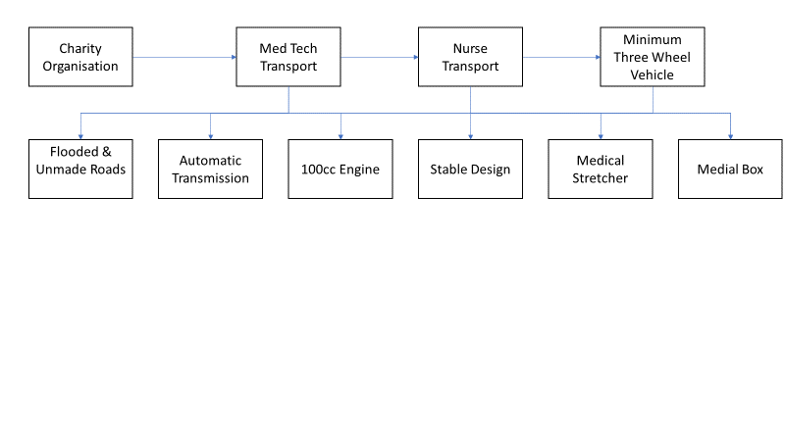

Figure 2 Requirement Objective Tree

Table 1 Customer Demands

|  |  |  |
| --- | --- | --- |
| **Customer Demands** | **Designers Thought** | **Importance Rating 1-10** |
| Nurse | Ability to Transport | 5 |
| Medical Technician | Med Tech to Transport | 5 |
| Stability | Durable Design | 10 |
| 100cc Engine | 100cc Supplied | 10 |
| Automatic Transmission | Supply Auto Transmission | 10 |
| Medical Box | Supply Medical Box | 5 |
| Stretcher | Supply Stretcher | 5 |
| Terrain Proof | Shield Components | 10 |

To begin we identified the problems of the customer and listed them with an importance rating from 1-10. Considering a vehicle with a 100-cc engine, with at least three wheels two options have been put forward to suit demand.

* Bike with sidecar
* Four-wheel quad bike

Taking the information provided by the charity organisation and the designers initial thoughts, a QFD chart has been utilised to determine which vehicle best suits the criteria. The QFD is the voice of the customer, we use the information/demands provided to conclude which vehicle to choose and why we should choose.

# **Quality Function Deployment**

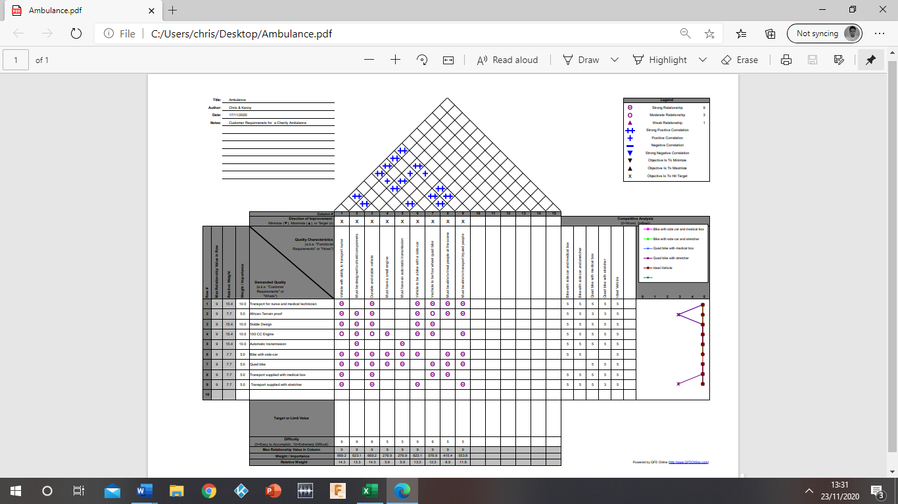

Figure 3 Quality Function Deployment



The QFD data has provided details of what is important to the customer and what the outcome should be. According to relative weight It has been determined that a bike with a sidecar is the most suitable method for transporting a nurse or Medical Technician whilst carrying a medical box, stretcher or both. The bike with sidecar has advantages over the quad bike as it sits higher off the ground which suits the flooded road criteria. It is also more compact in design; the quad bike would need to tow a stretcher making the overall vehicle much longer and harder to manoeuvre. However, the quad bike is suitable for carrying a medical box, the customer needs to clarify what vehicle they want and what do they want it for.

# **Pugh Matrix**

A simple Pugh Matrix chart has been formed to help the customer decide on the vehicle type.

Table 2 Pugh Matrix

|  |  |  |  |  |  |  |  |
| --- | --- | --- | --- | --- | --- | --- | --- |
| Pugh Matrix | | | | | | | |
|  | **Alternatives** | | | | | | |
| ***Concept Selection Legend***  Better +  Same S  Worse -   |  | | --- | | **Key Criteria** | | ***Importance Rating 1-10*** | Ideal Transport | Quad Bike fitted with Medical Box | Bike & Sidecar fitted with Medical Box | Bike & Sidecar fitted with Stretcher | Bike & Sidecar with Stretcher and Medical Box |  |
| Vehicle to Carry Medical Box | **5** | S | S | S | - | + |  |
| Vehicle to Carry Stretcher | **5** | S | - | - | S | + |  |
| Vehicle to Carry Stretcher and Medical Box | **5** | S | - | - | - | S |  |
| Sum of Positives | | | 0 | 0 | 0 | 2 | 0 |
| Sum of Negatives | | | 2 | 2 | 2 | 0 | 0 |
| Sum of Sames | | | 1 | 1 | 1 | 1 | 0 |
| Weighted Sum of Positives | | | 0 | 0 | 0 | 10 | 0 |
| Weighted Sum of Negatives | | | 10 | 10 | 10 | 0 | 0 |
| **TOTALS** | | | **-10** | **-10** | **-10** | **10** | **0** |

The customer has chosen the bike with sidecar which is able to carry a stretcher and medical box. They have asked the question as to why the quad bike cannot support a stretcher so a simple objective tree for the customer will help clarify.

# **Customers Objective Tree**

The objective tree simplifies the data given in the QFD. This chart is for the benefit of the customer, it gives and easy understanding to the problem of vehicle selection and offers a potential solution. The Objective Tree shows that the nurse and medical technician data has been passed on to the charity organisation regarding the vehicle problem. The charity has then liaised with the designers of our company who have offered a solution considering the constraints. The objectives are highlighted blue, the method, approach and information are given in green and the constraints in red.

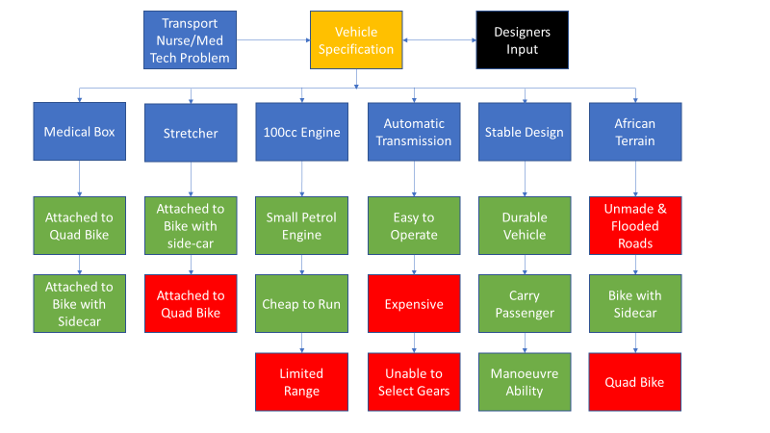

Figure 4 Customer Objective Tree

The customer is happy with the conclusion; however, they require an explanation for the constraints highlighted red.

## **Quad Bike**

A quad bike is suitable for a medical box but not a stretcher. The reason a quad is not suitable to incorporate a stretcher is because of its height, it runs low to the ground and flooded roads would be a problem. Also, the quad would need to tow a stretcher behind the vehicle causing stability issues on unmade roads.

## **100cc Engine**

Has a limited range, the average distanced of a vehicle with a 100cc engine is 70-90 Kilometres. Weight to power is an issue, but this can be solved using the correct engine and materials.

## **Automatic Transmission**

Is expensive compared to manual and adds extra weight lowering fuel efficiency. The other problem is the lack of manual gear change, manual gear selection is helpful in certain conditions. Having said that it produces higher torque ideal for hill climbs and makes the vehicle easier to operate.

# **Engineers Objective Tree**

This Objective tree is a more complex in-depth analysis for the designers to work with. Main objective values highlighted in blue were obtained using the weight/importance value data from the QFD chart totalling 65. The main objectives value is split over the sub objectives highlighted in green. The sub objectives are the thought behind the decisions made from the main objectives which are not clarified in the QFD.

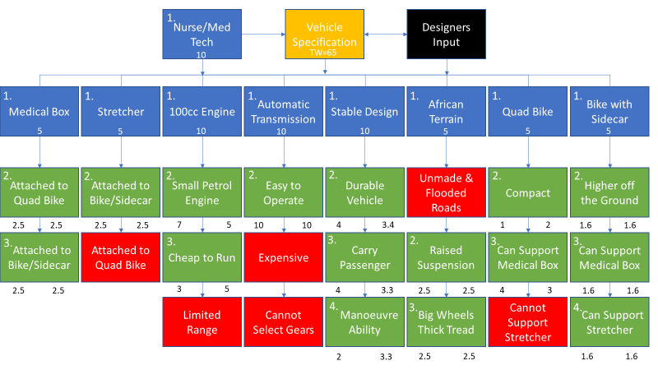

Figure 5 Engineers Objective Tree

From the Objective Tree the design team has also decided that the Bike with Sidecar is the most practical option which has also been agreed with the customer. For clarification for both customer and design team, the sidecar shall be transformed into a stretcher. We need to give it a name that suits the job it is intended for “The African Ambulance”.

## **Design Teams’ Further Input**

After a thorough investigation the design team have two further improvements to make to the design.

## **Problem with Sidecar**

The design team have researched and concluded you cannot buy a 100cc bike with sidecar because there is a power to weight ratio problem. Also, there is a difficulty converting a sidecar to support a stretcher, it is near impossible. However, the idea of the sidecar method is highly desirable. Fabricating a lightweight chassis from box aluminium will solve the problem for power to weight if we utilise the correct engine.

## **Additional Features**

The charity organisation wants this vehicle to be medical, to make it medical it has to include the following additional features.

* GPS
* Radio
* Siren
* Flashing Light

## **Customer Agreement**

The customer agrees on the fabrication of a lightweight sidecar chassis, and the additional features that make this vehicle an ambulance.

# **Product Design Specification**

Upon selecting the vehicle type, a Product Design Specification (PDS) shall be implemented. The PDS shows the attributes of the vehicle highlighting objectives and constraints. It shows what the vehicle must have to complete the task of transport and details the specification of the vehicle to be implemented. To help understand the PDS an Objective Tree has been provided to show the method of producing the African Ambulance.

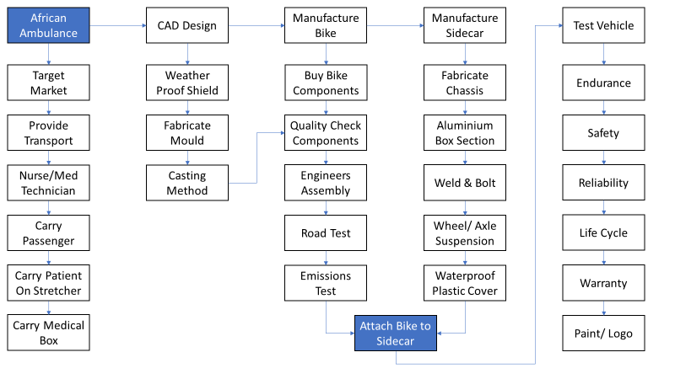

Figure 6 Design Method Objective Tree

## **Brief**

African Ambulance must consist of the following to be able to complete the objective.

* Must have 100cc engine
* Must have a 2-stroke engine
* Must be able to carry passengers
* Must be able to transport patients
* Must be able to carry medical supplies
* Must be stable in design
* Must be able to cope with terrain
* Must be waterproof
* Must have siren, flashing light
* Must have GPS and radio
* Must be lightweight

**Engine performance**

1) Capacity 100cc petrol engine

1.1) 2-stroke air cooled, 7 port torque induction.

1.2) Fuel capacity, 10.5 litres.

1.3) Emissions reduction using direct fuel injection system, thus, 100cc 2-stroke engine is permitted.

2) Horsepower = 11hp. 2-stroke engine better power to weight ratio than a 4-stroke.

2.1) Revolutions per minute (RPM) = 8500

2.2) Power Produced 0.746 Kw x 11hp = 8.2 (kW)

**Automatic Transmission**

3) producing higher torque for hill climb starts.

3.1) Automatic 4 speed gear box.

3.2) High Torque required to pull weight.

3.3) Easy operation, no gear changes required.

**Bike Speed**

4) Top speed = 110km/h

**Bike Dimensions**

5) Length = 2000mm

Width = 800mm based on handlebar distance

Height = 1600mm

5.1) Seat Height = 765mm

**Weight**

6) Unladen bike weight 100kg. Laden bike weight 250kg

**Wheels, Tyres, Suspension and Brakes**

7) Wire spoke design for bike, sidecar wheel ingress protection shield.

7.1) Front 64mm x 457mm (4ply)

7.2) Rear 70mm x 457mm (6 ply)

7.3) Sidecar tyre 70mm x 457mm (6 ply)

7.4) Wheelbase 1240mm

7.5 Bike suspension telescopic fork front, swing arm rear telescopic with spring. Sidecar 6 x suspension spring mounted to chassis and sidecar body.

7.6) Expanding drum, front and rear brakes.

**Environment**

8) African terrain consists of mud, dust and steep incline/declines.

8.1) Unmade roads present a problem with vehicle grip and ride comfort.

8.2) Flooded roads present a problem of rusted components and engine misfire.

**Stability**

9) bike with sidecar offers stability whilst retaining a lightweight vehicle.

9.1) Bike and sidecar standard three-wheel design.

9.2) Soft suspension system fitted to both bike and sidecar for harmonisation.

9.3) Thick tired treads provide stability and grip for unmade roads.

9.4) Vehicle to be a strong, durable, and light weight, fitted with extra weather protective materials especially for the engine components.

**Sidecar Dimension**

10) Area of Sidecar = 1.6m^2

10.1) Sidecar height = 1m

10.2) Stretcher = 1.8 x 0.7m^2

10.3) Sidecar = 2 x 0.8m^2

**Chassis**

11) Chassis material to be made from light weight box section aluminium, to be welded offering lightweight support maintaining strength.

**Passenger Protection**

12) Plastic waterproof membrane protecting patient/passenger from dust, rain and providing shade from the sun.

**Hitch Type**

13) Mounting bracket attaches bike to sidecar connected at extra protective engine cover. Sidecar axle bolted to bikes rear wheel right-hand-side fork. Connection includes light angle for bike leaning away from sidecar.

**Carrying Capacity**

14) Single bike rider, and 1 adult plus a mall child for the sidecar. Total 2.5 people.

**Lifespan**

15) Approximately 8-year life span, potentially 10 years if the 2-stroke engine is constantly maintained.

**Ambulance Features**

16) GPS System fitted to bike dashboard for location whereabouts.

17) Radio System fitted to bike dashboard for information liaison with hospital.

18) Siren System fitted to the bikes dashboard, facing the road ahead for emergency response awareness for public transport and pedestrians’ concerns.

19) Flashing light System fitted to break and headlights for emergency response, visual alarm. Red in colour to suit African ambulance specification.

**Aesthetics**

20) Black, silver and green, engine acrylic aerosol paint.

20.1) Ambulance logo signifies vehicle type.

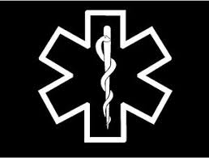

Figure 7 African Medical Symbol

**Safety**

21) Bike and sidecar require the following safety features to comply with regulations.

* 2 helmets
* Puncture repair kit
* Support jack
* Spare tyre
* Waterproof membrane
* Spare drive chain
* Fuel can
* Eye goggles
* Gloves
* Bike suit protection
* Hi visibility vests

**Cost**

22) Retail price of the bike and sidecar approximately £8000

* Build of the bike with manufactured parts plus labour £5000
* Manufacture of the sidecar plus labour £3000

**Manufacture Method**

23) The manufacture is to take place at the Chop & Swop factory.

1. Bike components to be brought from motorbike suppliers and assembled in house by mechanical engineers. Weatherproof component covers are to be made from aluminium. The moulds are designed by CAD technicians and manufactured in house by engineers using casting techniques. Shielding component covers are to be aeriated aluminium meshes allowing engine heat to escape whilst protecting components from terrain issues.
2. Sidecar chassis to be manufactured in house by welding aluminium box section forming a frame. A weatherproof membrane attached by assembly team using fasteners. Sidecar doubled hinged at the centre allowing easy access.
3. Axle and wheel fitted by engineers to sidecar, additional supports provided by welding and fasteners.
4. Bike and sidecar sent to be painted.
5. Bike is to be bolted and welded to sidecar for stability.
6. Logos attached to finished vehicle.

**Manufacture Build**

24) Buy a light-weight bike frame and fit components listed (1-5). Manufacture Sidecar and fit components (6-17)

Table 3 Manufacture Build

|  |
| --- |
| 1. Buy and fit 100cc, 2 stroke, engine with automatic transmission |
| 1. Buy and fit direct fuel injection system to engine for emission reduction |
| 1. Buy and fit suspension/brakes/wheels/tyres/seat/lights/handlebar/forks |
| 1. Manufacture and fit weatherproof material to protect bikes components |
| 1. Buy and fit GPS, radio, siren and flashing light to bike |
| 1. Fabricate sidecar chassis and stretcher from aluminium box section in house |
| 1. Fit suspension to chassis |
| 1. Fit axle and wheel to chassis |
| 1. Fit spare wheel underneath chassis |
| 1. Fabricate hinged drop panel for access to stretcher |
| 1. Fit plyboard to base of chassis using nuts & bolts |
| 1. Fit polystyrene or expanding foam between aluminium frame panels |
| 1. Encase aluminium frame panels with plastic waterproof membrane |
| 1. Use fasteners to secure membrane to chassis |
| 1. Weld and bolt sidecar to bike |
| 1. Fit additional supports |
| 1. Fit mattress to fabricated aluminium stretcher for comfort |

24.1 Factory tooling requirements.

* Welding machines
* Aluminium pressure die-casting machines
* Manual cranes
* Support benches
* Torque wrenches
* Hand tools
* Testing equipment
* Power tools
* Acrylic aerosol paint
* CAD programmes

24.2 Factory ergonomics

* 8 hour working day
* PPE provided
* Staff training
* Staff well being
* Relaxed atmosphere
* Regular maintenance of machines
* Sufficient workspace for staff
* COVID safe environment

**Test & Commission**

25) Bike tests after component assembly.

* Emissions test
* Durability test
* Electronics test
* Brake test
* Suspension test
* Engine test
* Road test

25.1) Sidecar Tests after fabrication and assembly.

* Durability test
* X-ray weld test
* Torque Test of bolts and fasteners

25.2)Bike & side car combination tests

* Road test
* Seat belt test
* Durability test
* Unmade road test
* Flooded road test
* Waterproof membrane test
* Comfort test

**Warranty**

26) Vehicle comes with a 3-year warranty. Chop & Swop guarantees to repair or replace a faulty vehicle during this time if the vehicle components are proven neglect free or defective. Wear and tear excluded from warranty cover. Warranty void after 36,000 miles.

**Target Market**

27) African nurse and medical technician transport.

* Hospital use
* Care home treatment visits for patients.
* Transport of staff.
* Emergency response
* Medical supply transport

## **Specification**

Table 4 Specification

|  |  |  |  |  |
| --- | --- | --- | --- | --- |
| **Number** | **Features** | **Requirement** | **Limitation** | **Demand/Wish** |
| 1  1.1  1.2  1.3 | Capacity  Engine type  Fuel capacity  Emission reduction | 100 cc petrol engine  2-stroke  10.5 L  Direct fuel injection systems | 70 – 90 Kilometre Range  35-kilometre radius  Emissions laws | Demand |
| 2  2.1  2.2 | Horsepower  RPM  Power | 11(hp)  8500 (RPM)  8.2 (kW) | Engine size 100cc | Demand |
| 3  3.1  3.2  3.3 | Transmission | Automatic single cylinder  4 Speed  High torque  Easy operation | No control of gear selection  Expensive | Demand |
| 4 | Speed | 110 km/h | 100cc Engine | Wish |
| 5  5.1 | Dimensions of Bike  Seat Height | Length 2000mm  Width 1600mm  Height 1600mm  765mm |  | Wish |
| 6 | Unladen Bike Weight | 100Kg | Laden 250kg | Demand |
| 7  7.1  7.2  7.3  7.4  7.5  7.6 | Wheel  Front  Rear  Sidecar  Wheelbase  Suspension  Brakes | Wire spoke  Front 64mm x 457mm (4ply)  70mm x 457mm (6 ply)  70mm x 457mm (6 ply)  1240mm  Telescopic  Expanding drum |  | Wish |
| 8  8.1  8.2 | Environment | African terrain  Unmade roads  Flooded roads | Non submersible | Demand |
| 9  9.1  9.2  9.3  9.4 | Stability  3 wheels  Soft suspension  Thick tired tread  Durable Design | Bike and sidecar  Front wheel offset  Sidecar Spring suspension  Grip  Shielded Components | 40-degree incline and decline | Demand |
| 10  10.1  10.2  10.3 | Area of Sidecar  Height  Stretcher  Sidecar | 1.6m^2  1m  1.8 x 0.7m^2  2 x 0.8m^2 | Weight | Demand |
| 11 | Chassis Material | Steel aluminium box section |  | Demand |
| 12 | Passenger protection | Reinforced plastic cover |  | Demand |
| 13 | Hitch Type | Mounting bracket |  | Demand |
| 14 | Carrying Capacity | Patients/ Medical staff | 1 adult and a small child | Demand |
| 15 | Life Span | 8 years |  | Demand |
| 16 | GPS | Location of whereabouts |  | Demand |
| 17 | Radio | Job details/ assistance |  | Demand |
| 18 | Siren | Emergency response | 124 decibel | Demand |
| 19 | Flashing Light | Emergency response | Blue, amber | Demand |
| 20  20.1 | African Ambulance Aesthetics | Black, silver and green paint  Ambulance logo | Hot components | Wish |
| 21 | Safety Features | Standard vehicle requirements | Long overcoats | Demand |
| 22 | Cost of Vehicle | £8,000 | Charity Affordability | Wish |
| 23 | Bike manufacture method  Shield components  Sidecar | bike components brought and assembled in house (1)  Weatherproof shields designed and manufactured inhouse (1)  Manufactured in house (2) |  | Demand |
| 24  24.1  24.2 | Manufacture build  Tooling Requirements  Ergonomics | See PDS  See PDS  See PDS |  | Demand |
| 25  25.1  25.2 | Bike test  Sidecar test  African Ambulance test | See PDS |  | Demand |
| 26 | Warranty | Covered for 3 years or up to 36,000 miles | Free service expires  Void after 36,000 miles | Demand |
| 27 | Target Market | African Nurse and Medical Technician |  | Demand |

(Yamaha RX 100 Price, 2020)

## **African Ambulance Features**

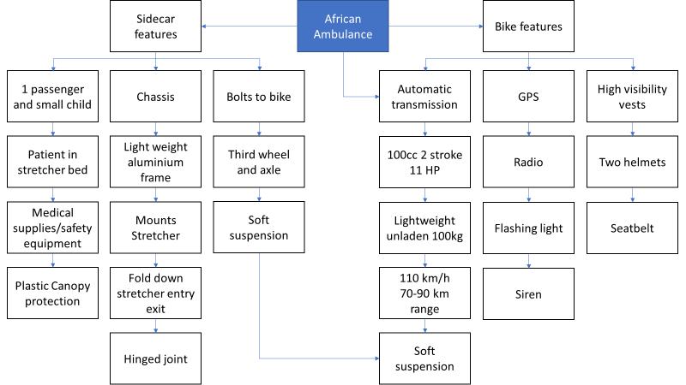

Figure 8 African Ambulance Features

## **Ability**

The African Ambulance transports people and healthcare resources to and from hospital and health centres. It can carry transport two people including a small child. The sidecar comes with a removable stretcher, a hinged joint drops the front panel allowing access to remove the stretcher once a destination has been reached. Generally, the sidecar and bike tow inwards however the bike tends to lean away from the sidecar.

## **Sidecar**

By design and expert advice, the bike is to slightly lean away from the sidecar and is to be bolted at an angle. Bolting the chassis first with the third wheel/axle and then the frame on top, the frame is raised to avoid flooded road problems. The stretcher sits on the chassis and can be laid down flat or raised, this depends if the vehicle is transporting a sick patient, supplies or medical personal. There is a little storage area at the rear of the car where the safety features and medical supplies can be accessed. A soft suspension system is used for patients and passengers’ comfort. A double canopy is supplied for when it rains or dust prevention covering the patient, supplies or passengers, they can be lifted from the centre point and be locked in place at each end. (Home Page, 2020)

## **Bike**

The bike itself is fitted with robust tyres and tread for harsh terrains, it also has a soft suspension system matching the sidecar. It comes fitted with GPS, radio, flashing light and siren. The bike has a 2-stroke engine giving better power to weight ratio than a 4-stroke producing more horsepower. An automatic transmission system provides extra torque for hill climbs. It has a top speed of 110 km/h with a 70-90-kilometre range. Additionally, the bike components such as the engine are housed and protected against mud, dust and flooded roads. (eRanger Ambulance | Engineering For Change, 2020)

# **Constraints**

Constraints are the limitations and parameters this design has to comply with.

## **Weight**

Weight is the biggest issue, to overcome this obstacle a lightweight steel bike frame and aluminium sidecar chassis is required. Using aluminium box section for the sidecar retains strength and removes weight. The design of the chassis is crucial, and the minimum amount of aluminium will be used. A plastic membrane is also a lightweight solution providing shelter from the weather and preventing dust from the roads. (Aluminium Box Sections - Aluminium Square Tubing | metals4U, 2020)

## **100cc engine**

This is the main limiting factor for weight, it is a small engine, if we select the right type of stroke we reduce weight and increase power. A 2-stroke engine has a better power to weight ratio than a 4-stroke doubling if not trebling horsepower for a faster bike. There was a problem with a 2-stroke engines and some are banned in certain countries because of the emissions released. However, new improved versions are equipped with direct fuel injection systems reducing emissions to legal requirement. (The rise and fall of the two-stroke » British Motorcyclists Federation, 2020)

# **Conclusion**

The African Ambulance designed to transport patients’ staff and medical supplies throughout Africa. A lightweight bike and sidecar with the ability to outperform existing hospital transport regarding unmade and flooded roads. Equipped with safety features, medical supplies, GPS, radio, flashing lights and siren. This vehicle has an automatic transmission, 2-stroke 100cc engine with fuel injection system reducing emissions. A lightweight yet powerful bike producing 11 horsepower and 8.2kW of power. It has a 10.5 litre petrol capacity giving a range of 70-90 kilometres. The bike itself has a top speed of 110 kmph reduced to 70-80 with the sidecar and extra shielding of components but that is still very fast and great for emergency call outs.

The sidecar consists of a lightweight sturdy aluminium frame with a spring suspension system in place providing comfort to passengers and patient. In total it can transport 2 adults and 1 small child. Extra protection has been considered protecting engine components from harsh terrain by offering lightweight removeable fine meshes stopping unwanted ingress whilst allowing the engine to breath. This expands the life of the vehicle, a robust aesthetically pleasing practical solution has been presented to the charity organisation to solve the problem they approached us with. The 2-stroke engine was a thing of the past but we at Chop & Swop aim to combine this old tech with new creating an emission legal vehicle utilising the power of a 2-stroke engine.

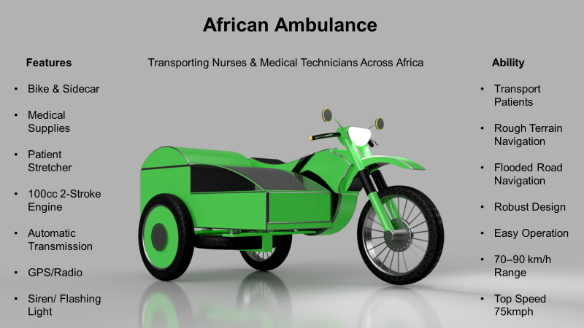

Figure 9 African Ambulance

# **References**

Yamaha RX 100 Price, I., 2020. Yamaha RX 100 Price, Specs, Mileage, Reviews, Images. [online] BikeDekho. Available at: <https://www.bikedekho.com/yamaha/yamaha-rx-100> [Accessed 1 December 2020].

Sidecars.org.uk. 2020. Home Page. [online] Available at: <http://www.sidecars.org.uk/info.html> [Accessed 1 December 2020].

Engineering For Change. 2020. Eranger Ambulance | Engineering For Change. [online] Available at: <https://www.engineeringforchange.org/solutions/product/eranger-ambulance/> [Accessed 1 December 2020].

Metals4u.co.uk. 2020. Aluminium Box Sections - Aluminium Square Tubing | Metals4u. [online] Available at: <https://www.metals4u.co.uk/materials/aluminium/aluminium-box-section> [Accessed 1 December 2020].

British Motorcyclists Federation. 2020. The Rise And Fall Of The Two-Stroke » British Motorcyclists Federation. [online] Available at: <https://www.bmf.co.uk/news/show/the-rise-and-fall-of-the-two-stroke> [Accessed 1 December 2020].